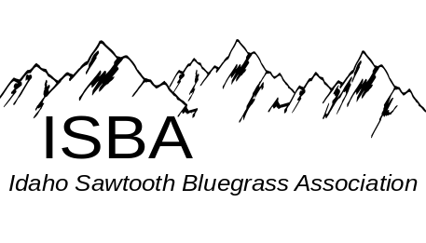
Volume 5 Issue 3 May - June 2009
Inside this Issue:

Bannock Co Bluegrass Festival . . . . . . .pg 6

Bluegrass Events Calendar . . . . . . . . . . pg 11

Darrington Bluegrass Festival . . . . . . . . pg 3

Friends of Bluegrass . . . . . . . . . . . . . . . . pg 8

Hardtimes Bluegrass Festival . . . . . . . . pg 9

Intermediate Jam at Fall Festival . . . . . . pg 8

ISBA Fall Festival . . . . . . . . . . . . . . . . . . .pg 10

Kootenia Bluegrass Festival . . . . . . . . . .pg 6

ISBA Membership Application . . . . . . . . pg 11

Message from the President . . . . . . . . . . pg 2

Spring Super Jam Pix . . . . . . . . . . . . . . . pg 4

MORE SPRING JAM PIX
Lori Palmer, the photographer from the Idaho County Free Press took MANY great pictures at Spring Super Jam. If you are interested in viewing and/or purchasing those photos you can see them at: http://www.idahocountyfreepress.com
Follow the blue button link “click here to see and buy photos” (R.H. side of the home page)

ISBA Monthly Jams
Southern Zone Monthly Jam – 7pm @ Gerties’ Brick Oven Cookery in Twin Falls.
Hot Jam, 1st Monday of the month
Slow Jam, 3rd Monday of the month
John Boyer 208-733-4552 boyerj1@mindspring.com
Middle Zone Jam – 7pm @ 5714 Centerbrook
Drive, Boise.
Intermediate Jam, 1st & 3rd Thursday of the month. Call Stan Strickland at (208) 377-5326 for more information. For a song list, contact Carolyn Johnson: cthorse@gmail.com
Northern Zone Jam - Noon to 5pm.
1st Saturday @ Orchards United Methodist
Church, 1213 Burrell Ave, Lewiston
3rd Saturday @ Highlander Community Room, 616 Warner, Lewiston
Steve Gleason 208-798-8280
Pete Northcutt 208-983-2277
During the summer months, please check with jam leaders to verify jams.
The purpose of the Idaho Sawtooth Bluegrass Association:
- To preserve and perpetuate Bluegrass music as a heritage of our country;
- To promote the education and enjoyment of Bluegrass music;
- To promote fellowship among all musicians and supporters who have a love for Bluegrass music, regardless of race, creed, color, ethnicity, or ability to play music.

IdaGrass

Message from the President


Spring Jam
The Spring Super Jam in Kamiah was a resounding success, thanks to the many volunteers and participants who effortlessly made the event into a seamless musical holiday. One of the very nicest elements of the week-end was the number of people who brought instruments and played. There were jams everywhere, and the pickers were a wonderful mixture of people of all ages. The food venders were excellent, the Kamiah resort personnel were gracious and helpful as always, and the resort facilities were very helpful for jammers on those cool spring evenings. We would especially like to thank those who brought tents for jammers. The tents, in addition to the resort facilities, provided a place for everyone to play music.
Our experiment with the intermediate jams was fun. They were well attended by good sports and willing learners. Our special thanks to Brian Haken, Steve Gleason, and Stan Strickland—each leading an intermediate jam. As an intermediate jammer myself, I enjoyed meeting and playing with people at my skill level. You may wonder how we define "intermediate jam." We do have a non-technical definition. It is a group of people willing to forgive and forget, who play songs everyone knows at a sensible speed. Our plan is to continue the intermediate jams and the same song list at the ISBA Fall Festival in Kamiah.
Kids in Bluegrass is growing and this year Raynae Redmond and her kids gave a fine performance on the main stage. We need to continue to support this effort. If you have a child or grandchild who could benefit from Kids in Bluegrass, bring them to the ISBA Fall Festival on Labor Day and let Raynae light their fire.
In case the previous paragraphs seem like self-congratulation, they are. However, it is backed up by a very kind review of the event written by Jim Sturgill in the newsletter published by the Idaho Bluegrass Association.
Special thanks needs to go to the bands who played Saturday afternoon: Will Williams and Gravel Road, Tradition, and Chicken Dinner Road. They all donated their services for the week end. Will Williams deserves a special thanks for handling the sound for the week-end.
Membership
We are still working on getting membership renewals. Remember, membership goes from April to April now. We thank those who renewed their memberships in May at the jam. If you haven't renewed in the last year, you can go to the web site at http://www.idahosawtoothbluegrass.org and find the address, application, and pricing, or you can call Trudee Strickland at (208) 377-5326 for more information.
ISBA Fall Festival
The ISBA Fall Festival is coming up in Donnelly, Idaho on Labor Day August 6-8 in Donnelly, Idaho not too far down the road from where we held last year's event. There are 40 full service camping areas and another 40

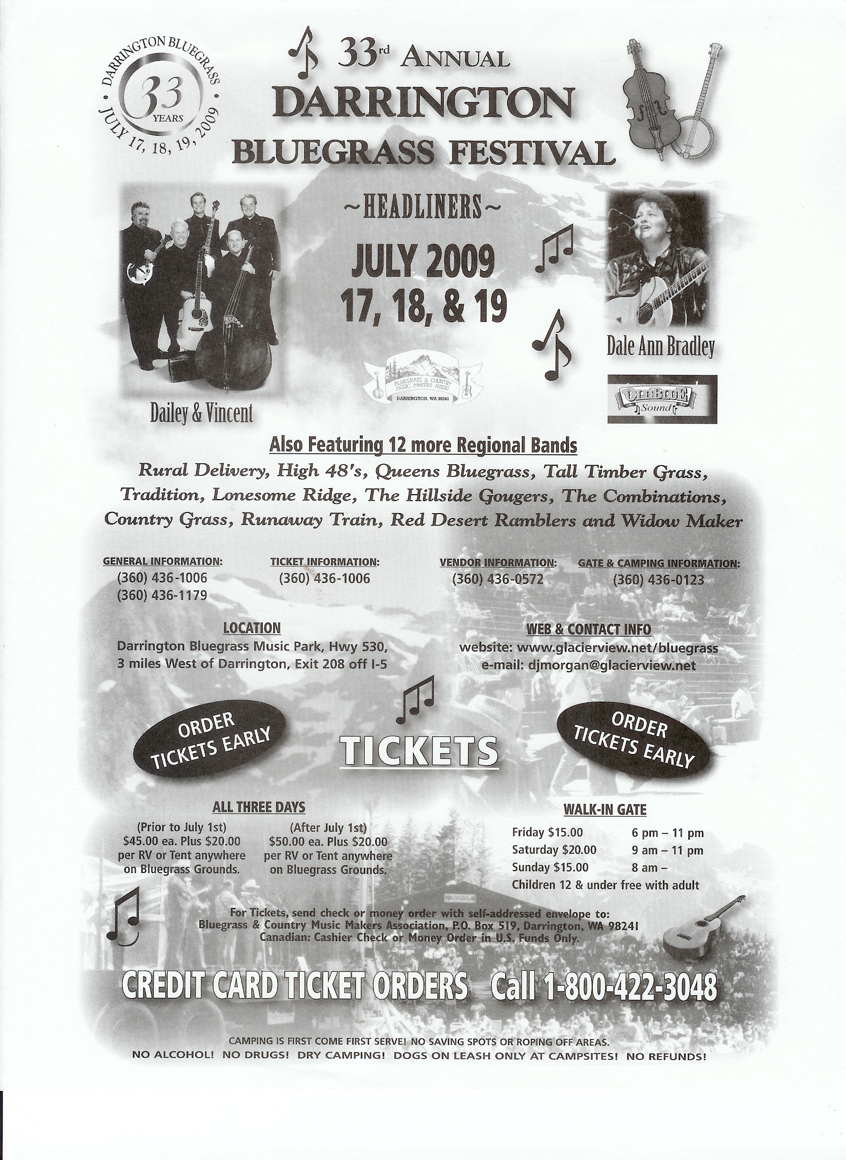

available for dry camping. It is a very short drive or a long walk to Cascade Lake from the campground. The organization is bringing in six fine bands, vendors, and our other activities, such as open mike, Sunday morning gospel open mike, intermediate jams, and Kids in Bluegrass. Telephone numbers of motels in the area are posted on the ISBA web site at http://www.idahosawtoothbluegrass.org. As more information about the ISBA Fall Festival becomes available it will also be posted on the web site.
Thanks to the Volunteers
I would like to write a special public thank you to volunteers listed below. You all made things go so well at Kamiah. No one had to work too hard, and we all had a lot of fun: Steve and Gail Gleason, Will and Gail Williams, Ann Williams, Brian Haken, Bob and June Greer, Dale and Loretta McMinn, Helen Smith, Karen Dostal, Harry Strang, Rue Frisbee, Stan and Trudee Strickland, Syd Howland, John and Raynae Redmond. My apologies if I have left anyone out. Let me know and I will fix it.
Carolyn Johnson, President ISBA

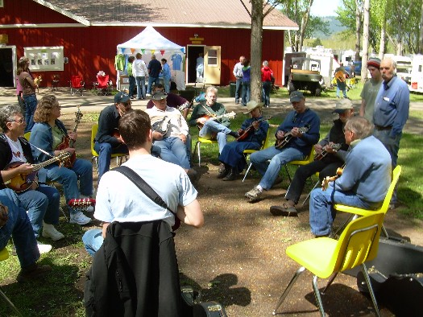
Herman Waldron and mandolin many learners
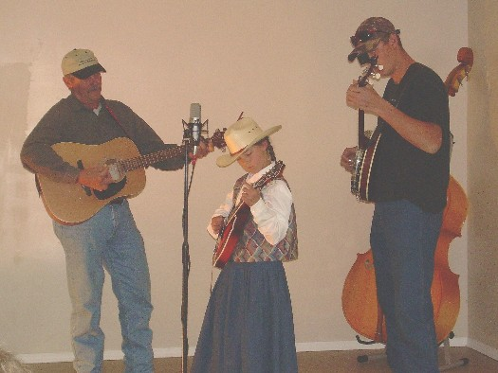
The Turner Family at Open Mic

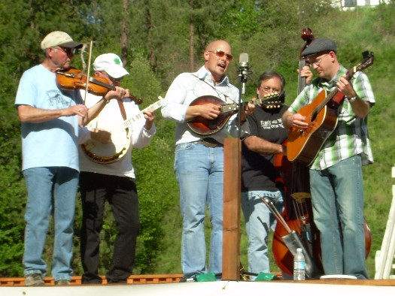
Chicken Dinner Road at concert

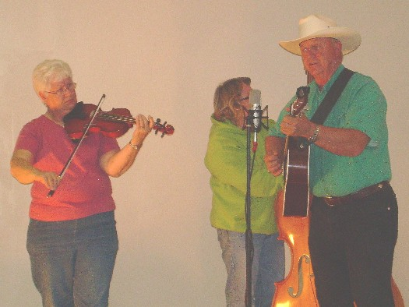
Marlene Moore (fiddle), Ron Moore (guitar) & Raynae Redman (bass) performing at Open Mic

Kootenia River Bluegrass and Beyond Festival
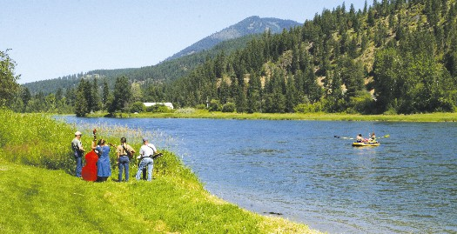
The Troy Fine Arts Council and the community of Troy invite you to our 2nd Annual Kootenia River Bluegrass and Beyond Festival. We feel this year’s line-up is even bigger and better then our first year event and promises to be one of the stellar line-ups of the summer all across the Pacific Northwest and Canada. We learned a lot from our first year and listened to the feedback from over 900 attendees that came for a taste of last year’s event. . Our line up this year is a great mix of the traditional sound of bluegrass, as well as the younger sound of the music that bluegrass has inspired for tomorrow’s pickers. Each band has its unique sound and could go toe to toe jamming with the Carter Family or Ralph Stanley. We are also reaching out to our Canadian neighbors, asking them to come on down and help us create a tradition. John Reischman and the Jaybirds don't need an introduction; Viper Central, from Vancouver BC, offers the pulse of what Canadian bluegrass has to offer; and Mighty Squirrel, showing us the roots of bluegrass that spread around the world, also has some north of the border roots.

Jackstraw, Loose Didgits, and Big Red Barn, three of the most sought out bands in the Inland Empire will show us why their pacific northwest is becoming headquarters for the national bluegrass scene. These bands, along with Bryan Bowers and his magical autoharp and storytelling, as well as Wise River Mercantile, a branch of Montana's infamous Broken Valley Roadshow, and Lincoln county’s own Ray and Shirley Jacobs, makes for a line up to live for.

We will continue to offer free dry camping on site for about 300 and will be working on the campground to make it more user-friendly. There will be motor home parking on site as well. We also will have satellite sites nearby for the overflow. If you are wondering about motels or all the possibilities of camping in our beautiful valleys, please check out our accommodation page on the web site. Our fees this year are $25 for 3-day pass with free camping on site when prepaid; $30 for 3-day pass at the gate with free camping; Friday $10, and Saturday $15.

The entire community of Troy is proud to be creating a tradition for the future of bluegrass in our area and will be offering discounts for restaurants and lodging. There will be a variety of food vendors, amazing instrument/vocal workshops from some of the best musicians in the northwest and enough jamming going on that you will continue to hear the sounds a week after the festival .We advise folks to purchase weekend passes on line to assure on site camping . Please help us spread the word near and far that Troy is ready and willing to become the mecca for the future of bluegrass in northwest Montana. With all of your support we just might do that. For more info see our website at www.krbgf.org or call Ralph @ 406-295-3016.

Looking for Fall Festival Volunteers
We are getting ready for the ISBA Fall festival over Labor Day and hope you have it on your calendar. The event is on Labor Day week-end, September 4, 5, and 6. We are looking for volunteers to help with this event. At this point we mostly need people who will sell tickets and sweatshirts. The board has voted to allow a 1-day pass for each 4 hours of work that you are willing to do. We are a non-profit organization and depend on volunteers and the proceeds of the Fall Festival to continue sponsoring events.
If you would like to volunteer, we would surely appreciate your help. We are trying to get our planning and scheduling done early because there are so many other things to do at the last minute. If you think you may be able to help, please contact Syd Howland at sydland1z@juno.com and she will work with you.

FYI – There will be no Bluegrass in the Barn in Nampa until September. Please support and enjoy some of the many other bluegrass festivals and shows this summer.

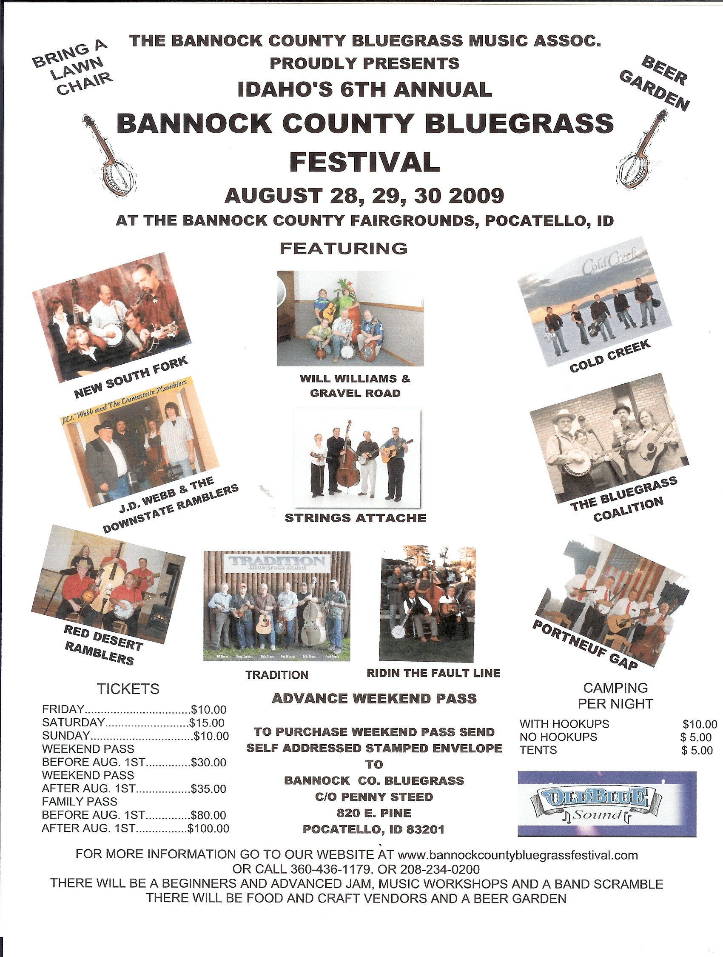

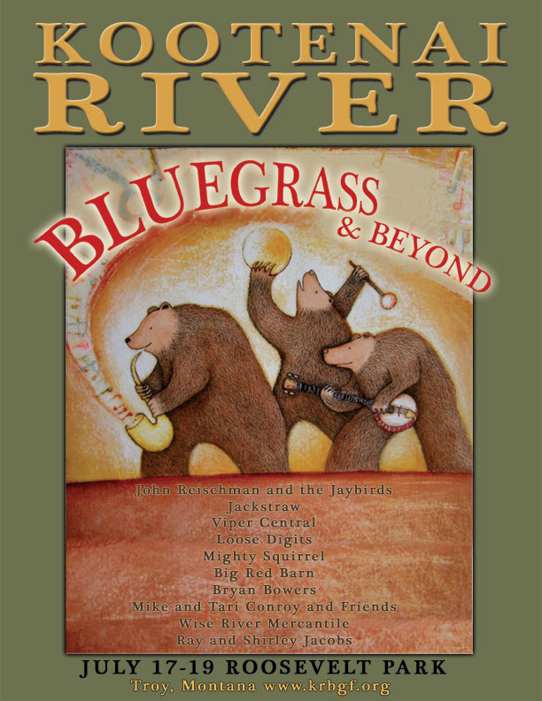

Intermediate Jam at the Fall Festival
Since there was interest in intermediate jams at the Spring Jam we will continue with three intermediate jams at the Fall Festival. We will keep the same song list so that you can keep practicing and really perfect these songs.
For those of you new to the idea, here is an outline of what our intermediate jams are about. They are for people who know their chords and can play at a moderate speed—about 150 beats a minute. Each organized jam has an experienced leader. No one cares if you make a mistake. We are there to support each other and give people a chance to play with other people without the pressure of an advanced jam. We are hoping that you will walk away from these jams with more confidence in yourself and perhaps even a new friend or two who will pick with you. We have a song list so that you can practice ahead of time. It was chosen by the three jam leaders in the Northern, Middle, and Southern Zones of the ISBA. We are specifying a key since it is tough for mandolins and fiddles to change keys because they don't have capos. This year's song list is:
1. Bury Me Beneath the Willow G
2. I'll Fly away G
3. Life is Like a Mountain Railway G
4. Lonesome Road Blues G
5. Salty Dog Blues G
6. Will the Circle Be Unbroken G
7. Gold Rush A
8. Rebekah B
9. Randy Lynn G
10. All the Good Times Are Past and Gone G
11. Fireball Mail G
12. No Mother Nor Dad G
13. Cripple Creek A
14. Old Joe Clark A
15. John Hardy A or G
16. Bury Me Beneath the Willow G
17. Maggie G
18. Cumberland Gap G

Friends of Bluegrass
In a time when the musical tastes in our culture have shattered into a thousand fragments, we cannot take it for granted that Bluegrass will survive and prosper. One reason that Bluegrass has endured is that at its roots are songs about common human experiences: family, love, values, the life of the spirit, and living in the natural world, not having everything you want but having what you need. On the flip side of the coin, reasons there are questions of whether Bluegrass will survive another 50 years are: that these common human experiences have so changed since the inception of Bluegrass that for many people who have grown up in broken homes and lived in cities all of their lives there is little to relate to in Bluegrass music; that there are large numbers of people in our country who find it difficult to understand the themes of Bluegrass music and to appreciate its acoustic nature, simple harmonies, and honest lyrics.
There are lots of reasons that Bluegrass should endure. It is just plain fun to listen to. Learning to play it is a creative intellectual exercise, matched only by learning to play jazz. Most importantly, it promotes a view of life in a simpler time when people lived with less of everything, maintained loving families, and tried (sometimes they struggled) to live an upright life, or were punished if they were really bad. Idealized? Yes. Something to work toward? Yes.
For this reason, it is important that we recognize those in our Bluegrass community who have made a special effort to be sure that Bluegrass survives another generation. Many of us appreciate the music. Quite a few of us work as volunteers for a Bluegrass organization. Some of us even play in Bluegrass bands. All of these roles are necessary for the genre to continue, and these people deserve our praise and thanks. Some people, however, have taken it upon themselves to be sure that Bluegrass gets seen and heard by the general public—often at some expense to themselves. These people deserve special recognition, specifically Bob Greer, DBR Productions (Dennis Stokes and Brian Haken), Will Williams, and J.D. Webb. Over the next few issues we will profile each of these leaders so that you will know more about who they are, what they do, and how to support them so that we can be sure that our music will be around for generations that come after us.

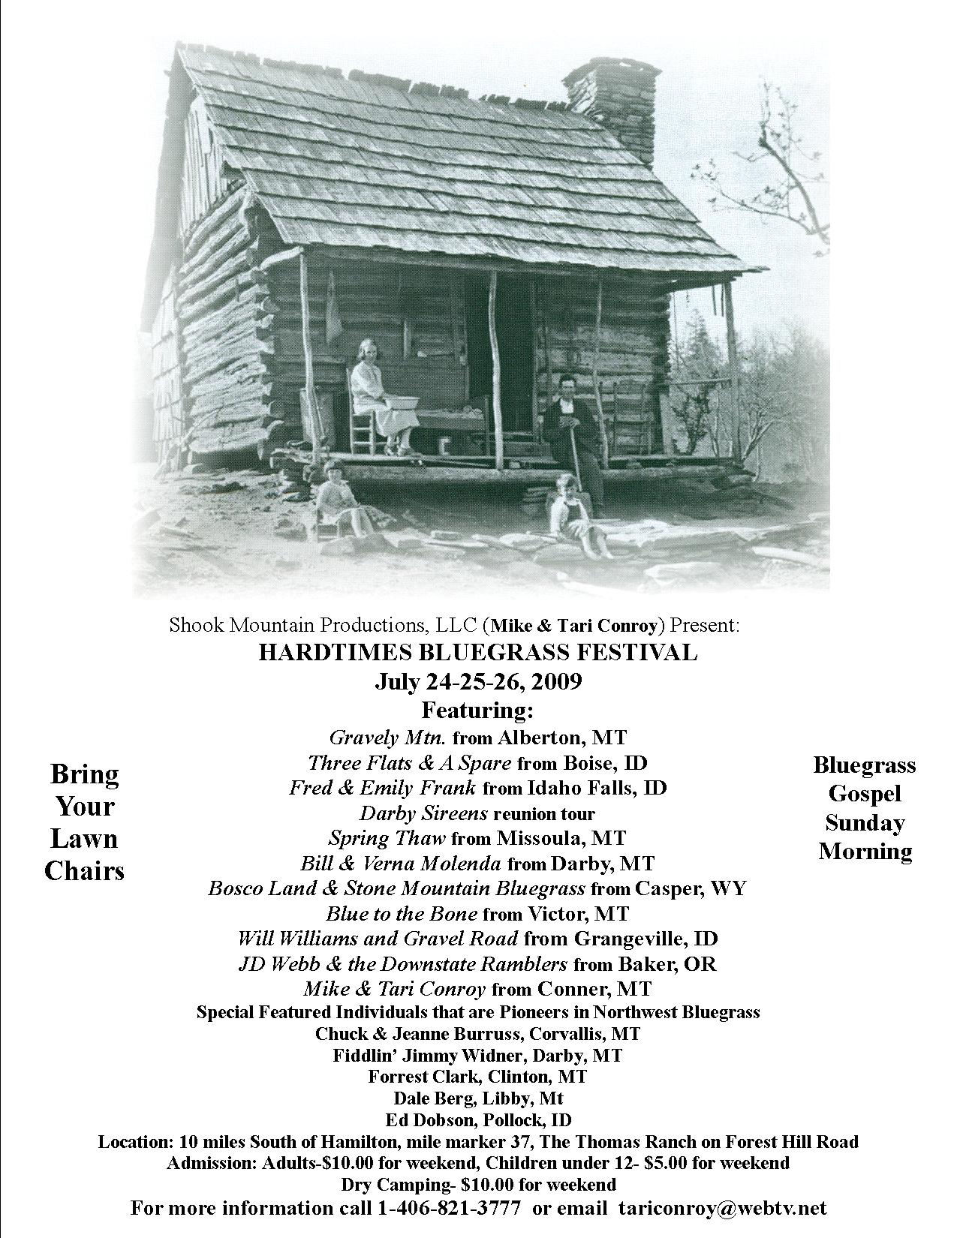

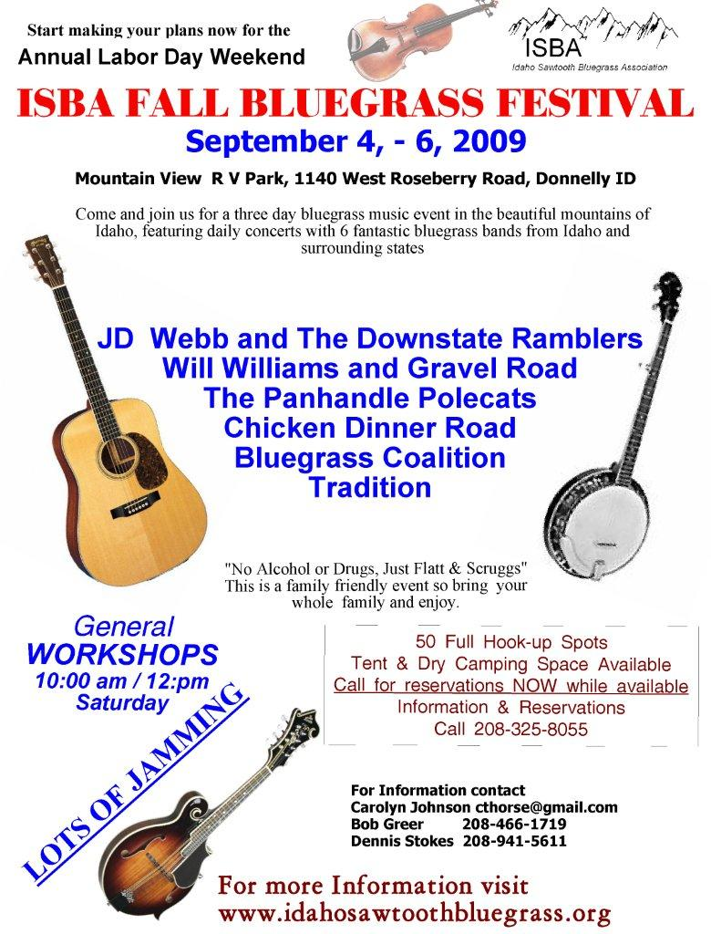
Bluegrass Events Calendar

June 20th

Workshops in Weiser – Intro to Jamming with Megan Lynch and Bill Evans, 2:30–3:30pm, $15. Megan Lynch/Vocal & Bill Evans/Banjo, 4–5:30pm, $25. For more into: contact Dennis Stokes:(208)941-5611 or dennisstokes@mac2.com or visit the website: dbrproductions.net

July 18th
Music on the Grass, Burley Golf Course and Boat Docks, Burley, Idaho
Bring the family for an evening by the Snake River and enjoy the Music and Food, with a Special Tribute to the American Veterans. Three great bands: Chicken Dinner Road, Strings Attached, and Will Williams and Gravel Road. (No ice chests or food allowed) This is a Fundraiser for the Local Meals-on-Wheels Program. General Admission, $10.
Contact Omar Alvarez 208-312-7025 George Maas 208-436-0151
Let’s keep the wheels turning for the needy in Mini-Cassia area… Let No One Go Hungry!

July 10th - 12th
The Moses Lake Camp ‘n’ Jam is moving to the St. Rose of Lima Catholic School in Ephrata. This is a great place to stay while on the way to the Darrington Festival. Early bird campers are welcome as early as the 6th of July. Call Dan Mittelstaedt, (509)-765-1006. (Formerly held April 30 - May 3 at the Grant County Fairgrounds, Moses Lake, Washington)

July 31 thru August 2
Bluegrass in the Blues –
bluegrass-in-the-blues@hotmail.com

Application for ISBA Membership

Name________________________________________________________________

Address______________________________________________________________

City____________________________ State________________ Zip_______________

Phone______________________Email Address_________________________________________
IdaGrass, the ISBA newsletter is offered either in email or printed letter format. Using email saves the Association
the cost of postage and printing. HOWEVER, because we want you to enjoy and look forward to the newsletter,
we want you to receive the newsletter in the format with which you are comfortable.

I would like to receive the newsletter: □ Email □ US Postal Service

I am joining as: □ New Member □ Renewal

Date:____________________

Yearly membership/April to April: $15 (for an individual or family)

Please mail to: Idaho Sawtooth Bluegrass Association
c/o Trudy Strickland
5714 Centerbrook Dr.
Boise, ID 83705

