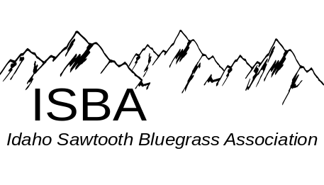
IdaGrass
Volume 5 Issue 1 January - February 2009

Inside this Issue:
Association Business ……………. page 3

Change in Membership Join Date...page 3

Contact Us………………………...page 9

Disk Space ………………………..page 4

IdaGrass Calendar…….…………..page 1

Membership Application………….page 3

President’s Message ……………...page 2

Carrie Hassler ...........................…...page 5

Neighboring Bluegrass Associations

Arizona Bluegrass Association –
www.azbluegrass.org

California Bluegrass Association –
www.cbaontheweb.org

Idaho Bluegrass Association –
www.smithfowler.org/bluegrass/IdahoBGindex.htm

Inland Northwest Bluegrass Association –
www.mtbluegrass.com

Montana Rockies Bluegrass Association –
www.mtbluegrass.com

Oregon Bluegrass Association –
www.oregonbluegrass.org

Washington Bluegrass Association –
www.washingtonbluegrassassociation.org

Bluegrass Events Calendar
Southern Zone Monthly Jam - 7pm at Gerties’ Brick Oven Cookery in Twin Falls.
Hot Jam, 1st Monday of the month
Slow Jam, 3rd Monday of the month
John Boyer 208-733-4552 boyerj1@mindspring.com
Middle Zone Monthly Jam –
Bill Elmer 208-466-1349 mandobil@mail2Musician.com
Bob Greer 208-466-1719
Northern Zone Monthly Jam, The Northern Zone is pleased to announce they are having two jams a month:
1st SAT at Orchards United Methodist Church, 1213
Burrell Ave., Lewiston Orchards, Noon - 5pm
3rd SAT at Highlander Community Room,
616 Warner, Lewiston Orchards. Noon - 5pm
Steve Gleason (208 798-8280
Pete Northcutt (208) 983-2277

NEW ! Middle Zone Jam –Intermediate jam every1st and 3rd Thursday at 7 pm. Call Stan Strickland at (208) 377-5326 for more information. Email Carolyn Johnson at cthorse@gmail.com for song list. Jam is held at 5714 Centerbrook Dr Boise, ID.
Bluegrass in the Barn, Saturday, March 14. 7:00 pm, Nampa ID. Don’t miss this wonderful evening when Tradition will be joined by Fred & Emily Frank. Open Mic to follow the band performances.
Bluegrass in the Barn, Saturday, April 18th. 7:00 pm, Nampa ID. Talented mucisians, Gary Eller and Rue Frisbee will join Tradition this evening as “Frozen Dogs”, Don’t miss it! Open Mic to follow the band performances.
Steve Kaufman in Concert, Saturday, May 16, 2009 7:30pm at the Orchards Baptist Church, 1002 Bryden Ave Lewiston, ID. Tickets - $10.00 per person, available at Lombard’s Music in Lewiston, (208)746-7127

The purpose of the Idaho Sawtooth Bluegrass Association:
- To preserve and perpetuate Bluegrass music as a heritage of our country;
- To promote the education and enjoyment of Bluegrass music;
- To promote fellowship among all musicians and supporters who have a love for Bluegrass music, regardless of race, creed, color, ethnicity, or ability to play music.

Message from the President


It is with humility that I step in to this job, taking the place of Bob Greer who for so long has preserved and presented traditional Bluegrass in the Treasure Valley. As President, Bob turned that drive and energy to making Bluegrass available to the State of Idaho. I also want to thank him for his support as we have made the transition. He said he would be my Number 1 volunteer and he is as good as his word.
I want give you an overview of the upcoming year. Besides sponsoring monthly jams in each zone, the ISBA sponsors The Kamiah Super Jam on Mother's Day and the ISBA Fall Festival on Labor Day. The Board has already been very busy getting ready for this year's events, and I would like to update you on changes and upgrades we are making in these two activities.
First, at both events we are going to sponsor jamming for intermediate players. We are going to generate a list of 10 tunes from the beginner/intermediate jams in each region and publish it on the web for people to see ahead of time. Then at the festival we will designate a jam area where intermediates can gather and play common songs from the list at a level with which they are comfortable. Songs on the list will remain the same for both events (Kamiah and the Fall Festival) so that intermediate players will have an opportunity to become proficient with these songs over the year. We hope that by the Fall Festival that intermediate jammers will be able to have a really satisfying jam experience.
Secondly, the Board is looking into providing tents for jamming as a long term goal for the organization. The Board hopes to have a tent for each zone. The zones will bring these tents to ISBA functions or use them for their own zone functions. At both the Kamiah Super Jam and the ISBA Fall festival, nights are chilly or there has been rain. Jamming has been inhibited by cold fingers and out-of-tune instruments. We are hoping that the addition of tents, and tents brought by members, will turn jamming at our events into a pleasant experience instead of an extreme sport. If you have a tent that is at least 10' by 20' and you don't use it any more, think about donating it to the ISBA. Your donation will be tax deductible and you could designate the zone to which you wish to donate it. If you know of a business that might make a tax deductible donation of a tent on which we would display the business name and logo, please contact one of the Board members.
Third, the Fall Festival will be held at Mountain View RV Park in Donnelly. Although we all loved the site last year on the Jim Kling ranch, we did not have what we needed to use that site again this year. Using it again required filling out a lengthy legal document for Valley County called a "Conditional Use Permit", paying at least $1500 for dust abatement, and a large crew of volunteers for site preparation. Although we have not ruled out that site for coming years when we have more money, more volunteers, and more expertise, the festival pre-planning committee recommended to the Board that we move the festival site to Donnelly. It is close to Lake Cascade where there is sand and swimming, there are a lot of trees and shade, it is a half mile from town and several good restaurants, and there are showers and electricity!
I look forward to serving you as your president. My goal is to have a Bluegrass tradition to pass on to our children and their children -- to preserve the old music and values on which it is based. I want to encourage the establishment of venues where people of all ages can hear and play the music whether they are a beginner or a pro. If you have comments, questions, suggestions, or observations please don't hesitate to contact me.
Carolyn Johnson

Change in Membership Join Dates

To simplify record keeping for the ISBA, membership, join dates will run from April 1st to April 1st, rather than from the date one joined for 12 months. All membership will be converted to the new system, effective January 1, 2009. Members whose memberships have expired since April of 2008 will fall into a grace period and automatically be renewed until April of 2009. Members who joined after April 2008, will be contacted individually to resolve this issue. We know this revision will be helpful to those who track membership. We hope it will be a positive change for our members and that you will remember to renew your membership in April as we kick off the bluegrass festival season with Spring Super Jam in Kamiah, May 8-10.
Thank You for your support!

Application for ISBA Membership

Name________________________________________________________________

Address______________________________________________________________

City____________________________ State________________ Zip_______________

Phone___________________________ Email Address___________________________

IdaGrass, the ISBA newsletter is offered either in email or printed letter format. Using email saves the Association
the cost of postage and printing. HOWEVER, because we want you to enjoy and look forward to the newsletter,
we want you to receive the newsletter in the format with which you are comfortable.

I would like to receive the newsletter: □ Email □ US Postal Service

I am joining as: □ New Member □ Renewal

Date:____________________

Yearly membership/April to April: $15.00 (for an individual or family)

Please mail to: Idaho Sawtooth Bluegrass Association
c/o Trudy Strickland
5714 Centerbrook Dr. Boise, ID 83705

Coming to Boise

Award-winning Bluegrass Band

IIIrd Tyme Out

April 14 2009

7:00pm

Special Events Center, BSU Campus
Doors opens at 6:30

Tickets $ 15.00, with student ID $10.00

Check the DBR Productions website for information about where to purchase tickets: www.dbrproductions.net

With special guests

Will Williams and Gravel Road
Produced by DBR Productions
Sponsored by Williams Custom Banjos

2009 Events & Festivals

MRBA Oldtime Bluegrass Festival, April 18
Stevensville High School, Stevensville, MT Sponsored by Montana Rockies Bluegrass Association: www.mtbluegrass.com

ISBA Spring Super Jam, May 8 - 10
Lewis Clark RV Resort, Kamiah Idaho.
See the flyer on page 2
www.idahosawtoothbluegrass.org

Weiser Warm-up Campout, May 15-17. Three Island State Park, Glenns Ferry, ID. Reservations must be made in advance through the State Parks Department.
Sponsored by the Idaho Bluegrass Association: http://www.smithfowler.org/bluegrass/IdahoBGindex.htm

Sacajawea Bluegrass Festival &
Dutch Oven Rendezvous, June 13-15
Sacajawea State Park, located near Tri-Cities (Richland, Kennewick and Pasco, WA) just off Highway 12.
www.sacajaweabluegrassfestival.com

Weiser Cool-down Campout, Sept 11-13. Three Island State Park, Glenns Ferry, ID. Sponsored by the Idaho Bluegrass Association: http://www.smithfowler.org/bluegrass/IdahoBGindex.htm

Darrington Bluegrass Festival, June 17-19. Darrington, WA. See website for latest news and updates: www.glacierview.net/bluegrass/

2nd Annual Kootenia River Bluegrass Festival, July 17-19, Troy Montana. 10 bands, 3 days of pickin’ on the banks of the Kootenia River. Free camping. For more information: musicalgraffiti@yahoo.com or www.krbgf.org

Hardtimes Bluegrass Festival, July 24-26. Hamilton, MT. An old-style bluegrass festival with a special tribute to the "Pioneers of Montana bluegrass". Dry Camping, no electricity. For more information contact:
Mike & Tari Conroy: tariconroy@webtv.net,
406-821-3777

Bluegrass in the Blues, July 31-August 2. La Grande, OR. A very relaxed weekend of camping and spontaneous acoustical Bluegrass & Old Time jamming.
http://mysite.verizon.net/res8aypu/

Blue Waters Bluegrass Festival, Aug 7-9. Medical Lake, WA. Sponsored By The Inland Northwest Bluegrass Association: www.bluewatersbluegrass.org.

Bluegrass in Swan Valley, August 14-16. City Park, Swan Valley, ID. Jamming at Art in the Park. For more info see the article, page 6
Bannock County Bluegrass Festival, August 28-30. Bannock County Fairgrounds, Pocatello, ID. www.bannockcountybluegrassfestival.com/
ISBA Round Valley Bluegrass Festival, Sep 4-6. Donnelly, ID
Mountain View RV Park www.idahosawtoothbluegrass.org

Pend Orreille Valley Bluegrass Festival, September 11-13. Newport, WA.
http://www.pvbluegrass.com/

Bluegrass Appreciation Day, Sept 20. Boise, ID. Calliope Gardens, Nampa Civic Center, Nampa ID. Sponsored by the Idaho Bluegrass Association: http://www.smithfowler.org/bluegrass/IdahoBGindex.htm

Visit the ISBA Website for photos of past events, flyers for upcoming
events and more: www.idahosawtoothbluegrass.org

Bluegrass in Swan Valley
Our friends in Eastern Idaho are working to start and build a Bluegrass tradition there. This summer they would like to invite Bluegrass jammers from the ISBA to Swan Valley to jam and play at Art in the Park on August 14, 15, and 16th. All proceeds from this event will be donated to the Arts Program in the local schools. We will have more about this event in the next newsletter. In the mean time, as you plan your summer think about a trip to this beautiful valley in August.

Flatpicking Workshop & Concert by Steve Kaufman
May 15 & 16th in Lewiston ID.
8-hour, all-level, hands-on flatpicking workshop scheduled for Friday, May 15th and Saturday, May 16th. Cost: $90.00, workshop times: FRI/ 7pm - 9pm, SAT/ 9:30am - 3:30pm. For more information, or to sign up, contact Scott Lombard at Lombard’s Music at 208-746-7127 or stop by at 1401 21st Street in Lewiston. Enrollment is limited and pre-registration is required.

Mandolin and Banjo Workshops
In conjunction with IIIrd Tyme Out coming to Boise, band members Wayne Benson and Steve Dilling will be conducting a mandolin and banjo workshop, respectively.
Date: Tuesday, April 14th
Time: 2:00 - 4:00pm
Location: TBA
Cost: $50.00
Register by April 7th and you will receive one free concert ticket with your paid workshop registration.
If you are interested in learning from these exceptional musicians or need more information, contact Dennis Stokes, at DBR Productions: dennis@dbrproductions.net or visit the DBR Production website - http://www.dbrproductions.net/

Song List for Intermediate Jam
Below is a song list for the intermediate jam compiled by the three zones. We will use this list for both the Kamiah Super Jam and the ISBA Fall Festival in Donnelly. We will have a designated jam area for intermediates with a jam master to help with organization and music questions. We are hoping that some of you who have never played in a jam before will feel comfortable playing in this one. There will be no pressure to do breaks if you want to work on your back-up skills. We will play at a moderate easy, pace. Most of all, we want it to be fun.
1. Bury Me Beneath the Willow - G
2. I'll Fly Away - G
3. Life is Like a Mountain Railway - G
4. Lonesome Road Blues - G
5. Salty Dog Blues - G
6. Will the Circle Be Unbroken - G
7. Gold Rush - A
8. Rebekah - B
9. Randy Lynn - G
10. All the Good Times Are Past and Gone - G
11. Fireball Mail – G
12. Rank Stranger -
13. Cripple Creek - A
14. Old Joe Clark - A
15. John Hardy - A or G
16. Maggie - G
17. Cumberland Gap - G

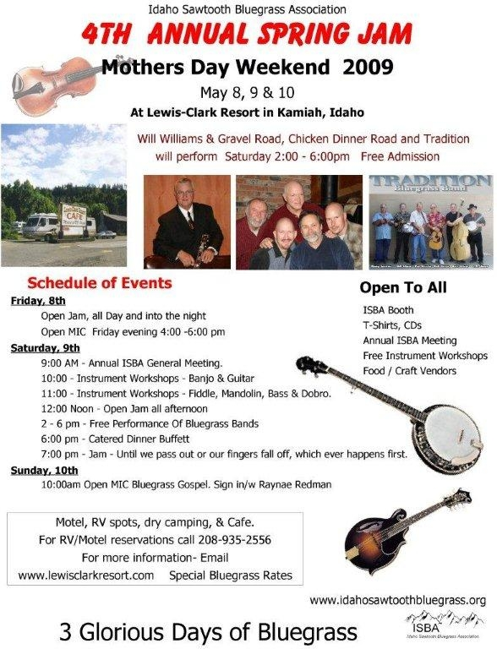

“Jammin” the Florida Way
Recently, I was fortunate enough to go on a bluegrass cruise with most members of the band, “Will Williams and Gravel Road,” and on the layover day before flying home, I was invited to a bluegrass jam down in Ft. Lauderdale, FL. Gerry, a friend that I’d met in the airport following the 2008 IBMA and who lives in Florida, invited my husband and me to come to the jam. It was certainly a good way to spend the layover day, rather than sitting in the hotel room.
I wasn’t sure what to expect because sometimes the term “bluegrass” can be used very loosely, and me being the “purist” that I am, headed to the jam with a little trepidation in my step. He had told me that it was a loose jam but that it was fun. We pulled up at the Fern Forrest Wildlife Refuge where the jam was to be held and it was a beautiful haven in the middle of a large city. There was a large covered pavilion with built in benches and a stage up front. Both musicians and spectators began to file in as he helped set up the sound system and soon the jam began. There were about a dozen bluegrassers who turned out, and around 100 spectators. As the jam began, it was clear that yes, indeed this was going to be “a good bluegrass jam”, a bit crazy, and wild, but at least the people knew their bluegrass and were playing traditional bluegrass. So, immediately I was happy to be there. Several people at a time would take the stage and one person would call out a tune that the core musicians would then support and play along to taking breaks, or joining in on the harmonies. Then a few of them would step off the stage and some others stepped up as the music kept flowing one tune after another, with hardly time to change a capo between the tunes. The non-stop jam continued for 2 hours. The enthusiastic crowd clapped along and sang to each tune. I especially enjoyed watching the elderly people who clearly were enjoying the moment. It was very fun and I enjoyed a sunny warm winter day jamming “Florida Style.”
“Cuzin’ Ray”, Raynae Redman
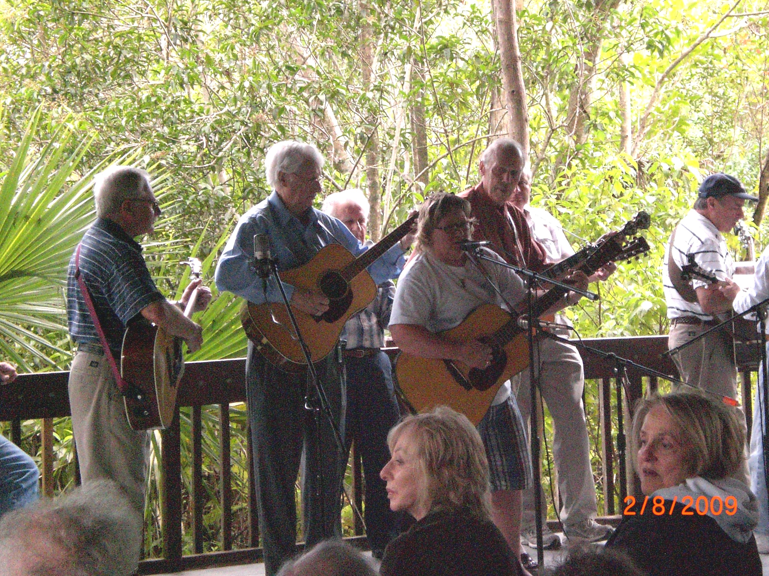

On the Road with the Gregg’s
We so enjoy playing music that is was hard to stay in Lewiston for the month of September, but Carol was on jury duty, started practicing on a set of songs that we wanted to record with Mike Conroy. Carol was released from her duties in late September so called Mike and sent him the list of songs. The recording went well and it was reviewed in the Nov/Dec newsletter. Thank you very much for a great review as we really loved doing this one. Carol visited daughters and grandkids before leaving for the winter.
We love music, lots of different music. We have played with country western, blue grass, southern bluegrass, gospel and pop and a tiny bit of jazz. We have played with musicians from Texas, Colorado, Utah, California, and, of course, Arizona. It was great this winter with us doing a couple of performances at RV parks. We also attended Bluegrass Festivals in Blythe and Havasu Landing. See you all in the spring, hopefully, at Hoots or the Spring Super Jam in Kamiah.
Love to all Rich & Carol Gregg

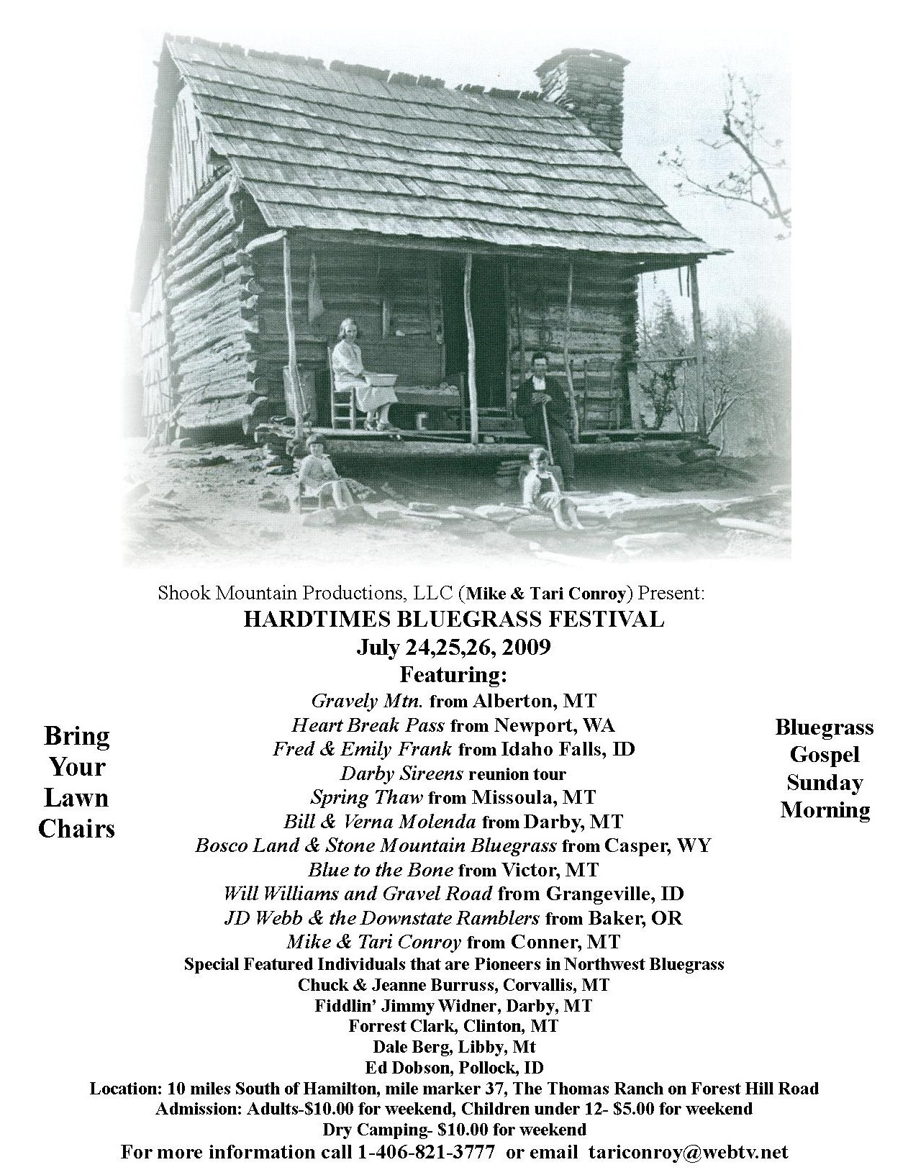 If you have Ideas, Comments, Questions, or Concerns
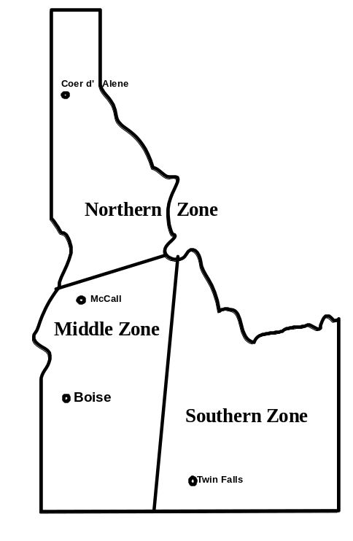

ISBA President – Carolyn Johnson

cthorse@gmail.com

Northern Zone

Steve Gleason, Lewiston

(208)798-8280

Pete Northcutt, Grangeville

pnorthcutt@mtida.net

Southern Zone

John Boyer, Twin Falls

(208)733-4552
boyerj1@mindspring.com

Middle Zone

Bill Elmer, Nampa

(208)466-1349
mandobil@mail2Musician.com

Bob Greer, Nampa

bobggreer@msn.com
(208)466-1719
Stan Strickland, Boise
(208)377-5326

Board Chairman - Will Williams, White Bird

will@williamscustombanjos.com

Webmaster - Carolyn Johnson, Boise

cthorse@gmail.com

IdaGrass Editor: Helen Smith, Grangeville

trueblue@wildblue.net

