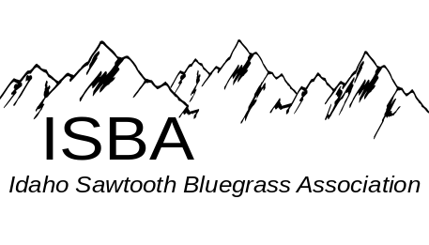
IdaGrass
Volume 4 Issue 2 March - April 2008

Inside this Issue:

Bluegrass Associations……………page 3

Bluegrass Festivals….…………….page 5

Contact Us………………………...page 9

Disk Space………………………...page 3

IdaGrass Calendar…….…………..page 1

From the Editor’s Desk……..….....page 5

Membership Application………….page 9

Message from the President…........page 2

Round Valley Festival …………...page 8

Buckhorn Mountain Boys………..page 6

Spring Super Jam ………………..page 4

Ten Jammandments………………page 7

ISBA Website:
www.idahosawtoothbluegrass.org

Bluegrass Events Calendar
Southern Zone Monthly Jam - 7pm at Gerties’ Brick Oven Cookery in Twin Falls.
Hot Jam, 1st Monday of the month
Slow Jam, 3rd Monday of the month
John Boyer 208-733-4552 boyerj1@mindspring.com

Middle Zone Monthly Jam –
Bill Elmer 208-466-1349 mandobil@mail2Musician.com
Al Jackson Bmbbluegrass@aol.com
Bob Greer 208-466-1719

Northern Zone Monthly Jam, The northern Zone is pleased to announce they are having two jams a month:
1st SAT at Orchards United Methodist Church, 1213
Burrell Ave. Lewiston Orchards. Noon - 5pm
3rd SAT at Highlander Community Room,
616 Warner, Lewiston Orchards. Noon - 5pm
Steve Gleason (208) 798-8280
Pete Northcutt (208) 983-2277

Bluegrass In The Barn – April 12th, 7pm, will feature The Council Mountain Bluegrass Band will join the house band, Tradition

Cedar Hill and Sugarfoot Express, May 1, 2008 - 7pm. Friends Community Center, Star ID.
www.dbrproductions.net
www.cedarhillbluegrass.com

Bluegrass In The Barn – May 17th, 7 pm, will feature Will Williams & Gravel Road will join the house band, Tradition

The purpose of the Idaho Sawtooth Bluegrass Association:
- To preserve and perpetuate Bluegrass music as a heritage of our country;
- To promote the education and enjoyment of Bluegrass music;
- To promote fellowship among all musicians and supporters who have a love for Bluegrass music, regardless of race, creed, color, ethnicity, or ability to play music.

Message from the President
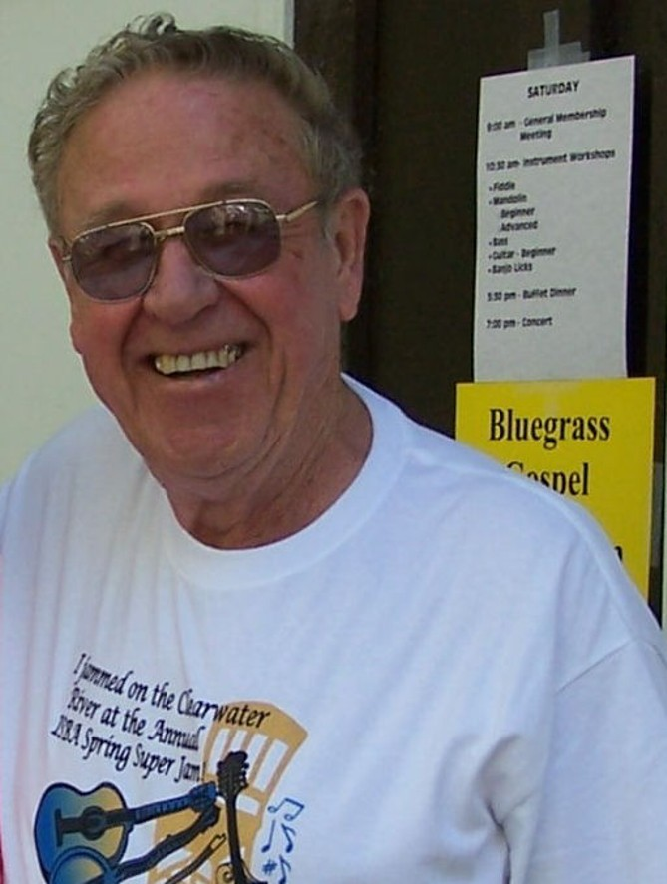
It is already April and the Spring Super Jam at Kamiah is fast approaching. I am looking forward to the Super Jam this year with great anticipation. From everything I hear from Pete Northcutt, this will be even better than last year. The new management at the Lewis-Clark Resort is making a lot of improvements to help facilitate our event. Let’s all show our support for the ISBA and bluegrass music in general. I hope to see you all there.
We are one step closer to the ISBA Festival at Round Valley on Labor Day weekend. The festival committee has started work on the project and some progress has been accomplished. This is already taking on the appearance of a festival effort of a much larger scale with greater possibilities than anything we have attempted in this area to this date. It is encouraging to have a committee made up of dedicated volunteers that are ready to get the job done and be a part of putting the Round Valley Bluegrass Festival on the map. I thank you all for re-enlisting.
Sydney Howland will be in charge of volunteers again this year. We definitely need all the help we can get to make this festival a success. If you want to be part of history please consider being involved in helping create our own Boise area, Labor Day Bluegrass Festival. The Round Valley site has great potential, but it is up to all of us who love Bluegrass Music to pitch in and make it happen.
Contact info for Sydney
sydland1z@juno.com
206-542-7591
Keeping the Tradition,
Bob Greer, President ISBA

Do you have a favorite bluegrass instructional book, CD or DVD? Or something that has helped you in your bluegrass learning?
Last month I invited members to share ideas, products or other that help them in their bluegrass learning. If you didn’t have time to drop me a note, I would still love to from you.

From Mike McCarthy, Twin Falls:
I learned by slowing down records, 33 rpms to 16 rpms, and having tablature. I needed both at first. My ear got better, to where I didn’t need the tab. Then I started using a Marantz tape player. You had to tape the records onto a cassette. Now I use the Audacity program on the computer. You need a program to create MP3s out of your CDs (I use Lame FE), and then you just open the MP3 with Audacity. You can slow any section of the tune down, as slow as you want, without affecting pitch. You can make a loop out of a particular lick. It’s amazing. It was cool back then, but there was definitely more guess work.
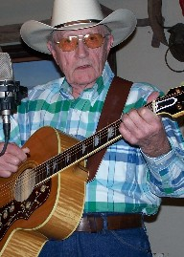

Bill Bledsoe, former Southern Gospel Heir
(Photo byJim McCue)

Disc Space by Mike McCarthy
ISBA Member, Mike McCarthy lives in Twin Falls and thinks, “you can never have too much banjo.” Mike has agreed to share and review newly released, and other CDs, with our readers

No Speed Limit, "Sweet Virginia"
Arhoolie Records, www.arhoolie.com

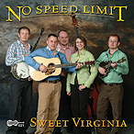
Good bluegrass requires three things: great lead singing, great songs and great banjo. These guys (and gal) have all three. This is a young bluegrass band from Virginia who were part of the “Crooked Road” Tour. The lead singer, Amber Collins, has a strong, clear voice that I really enjoy. The banjo picker, Stevie Barr, can play hot licks, but chooses not to. Instead, he plays what is best for the song or arrangement. His playing on the slow, under-stated songs was most impressive. There are four or five interesting and pleasing original songs, most of them written by Stevie Barr. One song (“Henry Box Brown”) that really stands out tells the tale of a slave who had himself mailed to the north in a wooden box to escape slavery. The guitar player, Josh Pickett, is no slouch. He won the Merle Fest guitar contest when he was seventeen, and there are several tunes that feature his playing. The band is rounded out by Ryan Blevins on mandolin and Jacob Eller on bass. They were great in concert, and this CD is well worth your hard earned money. This is traditional bluegrass with a modern twist played by outstanding, young pickers with lots of great energy.

Chatham County, "Speed of the Whippoorwill"
Yep Roc records, www.chathamcountyline.com

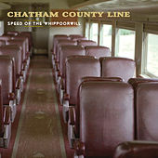
This North Carolina band won the Rocky Grass band contest the year that our band didn’t. They demonstrate what hard core bluegrass people know: that each band can develop its own unique sound even though they are playing within the traditional vein. They definitely have a distinctive sense of timing that reminds me of the Foggy Mountain Boys (you know, the guys who made Lester and Earl sound good). The lead singer and guitar player, Dave Wilson, wrote most of the tunes. I especially liked these lines from his song called, “They Were Just Children,” “One last hour, to slave at the mine, you boys are worth more, than what a miner can find. “ There is a nice Scrugg’s style instrumental written by banjoist (yes, that’s a real word, I looked it up), Chandler Holt and the mandolin player, John Teer. There isn’t a lot of fancy, hot picking, (and two songs did have pedal steel), but it is a good and interesting CD. This band has definitely carved out its own unique niche within the traditional sound that is worth checking out. They are a friendly group of guys as well.

Neighboring Bluegrass Associations -
This summer, if you are looking for a bluegrass jam or festival, you should check the websites of our neighboring associations. They might just be having a great event that’s not to far from where you are or where you might be traveling.

Arizona Bluegrass Association –
www.azbluegrass.org

California Bluegrass Association –
www.cbaontheweb.org

Idaho Bluegrass Association –
www.smithfowler.org/bluegrass/IdahoBGindex.htm

Inland Northwest Bluegrass Association –
www.mtbluegrass.com

Montana Rockies Bluegrass Association –
www.mtbluegrass.com

Oregon Bluegrass Association –
www.oregonbluegrass.org

Washington Bluegrass Association –
www.washingtonbluegrassassociation.org
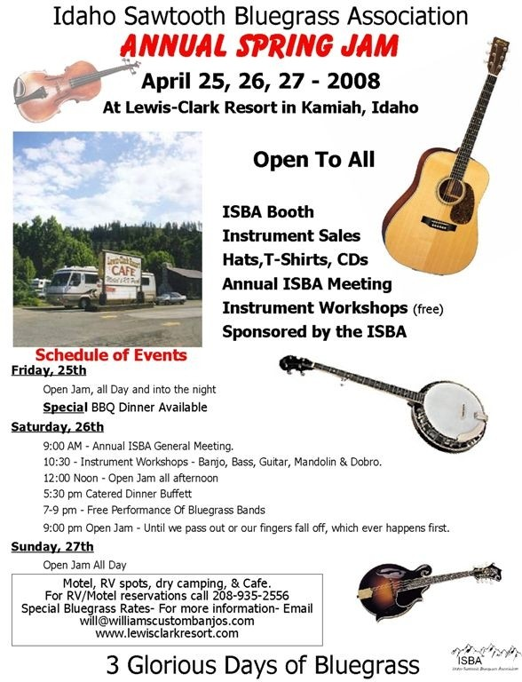

Bluegrass Festivals
MRBA Oldtime Bluegrass Festival, April 12
Stevensville High School, Stevensville, MT Sponsored by Montana Rockies Bluegrass Assoc: www.mtbluegrass.com

Schedule
12:00 Kids in Bluegrass
12:35 Chester Rudyard and Mullan Road
1:10 Blue to the Bone
1:45 Three Rivers Bluegrass
2:20 Bill and Verna Molenda Group
2:55 Leftover Biscuits
3:30 The Accousticals
4:05 Salmon Valley String Band
4:40 Porter Creek
5:15 Mike and Tari Conroy Group
5:50 Pinegrass
6:25 Too Hot to Handle
7:00 New South Fork
7:35 Will Williams and Gravel Road
8:10 Chick Weed
8:45 Gravely Mountain Boys
9:20 Ramblin Rose
9:55 Black Mountain
10:30 Greg Boyd Group

ISBA SPRING SUPER JAM, April 25-27
Lewis Clark RV Resort, Kamiah, ID
See the flyer on page 4
www.idahosawtoothbluegrass.org

SACAJAWEA BLUEGRASS FESTIVAL & DUTCH OVEN RENDEZVOUS, June 13-15
Sacajawea State Park, located near Tri-Cities (Richland, Kennewick and Pasco, WA) just off Highway 12.
www.sacajaweabluegrassfestival.com

BITTEROOT VALLY BLUEGRASS FESTIVAL, July 11-13
THIS FESTIVAL HAS BEEN CANCELLED.
www.mtbluegrass.com

BANNOCK COUNTY BLUEGRASS FESTIVAL, August 22, 23, 24
Bannock County Fairgrounds in Pocatello Idaho
www.bannockcountybluegrassfestival.com

ISBA ROUND VALLEY BLUEGRASS FESTIVAL, August 29-September 1
Round Valley, Idaho (just south of Cascade, ID on State Hwy 55)

From the Editor’s Desk. . .
First off, I would like to extend a special “thanks” to Jim McCue. He is always there with his camera, visually recording bluegrass events. A picture really is worth a thousand words and his photos enrich and enhance nearly every issue of IdaGrass. Thanks, Jim!
Well, the daffodils are peeking up through the dirt in my flowerbed, so I know spring is well on its way. With one of the first events of the season, the Spring Super Jam, just a couple of weeks away, I decided it wouldn’t hurt any of us to brush-up on our jam etiquette. I have included a copy of the “Ten Jammandments.” In my experience, those who play bluegrass have always been gracious and encouraging in my bluegrass learning. They have always been happy to answer questions, but we each have a responsibility to learn the basic ground rules and go from there.
If you have not yet had the chance to attend the Spring Super Jam, I would extend my personal invitation. It is a wonderful time to get geared up for the summer bluegrass season. There is an “Open Mic” on Friday night and a free concert on Saturday evening. The RV Park has been terrific to accommodate us and the setting is relaxing and pleasant. It is a wonderful weekend full of one of the things we most like to do, “jamming.” I love guidelines, “Open Jam – Until we pass out or our fingers fall off, whichever happens first.” I hope to see you there. Helen ☺

Buckhorn Mountain Boys
Bluegrass in the Barn March 15, 2008
My personal thanks and best wishes to each member of the Buckhorn Mountain Boys.
As a band, you’ve consistently set an example of excellence and we will miss your combined contribution to bluegrass in our neck of the woods. Good luck in your new ventures!
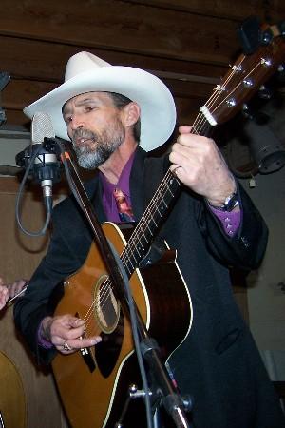
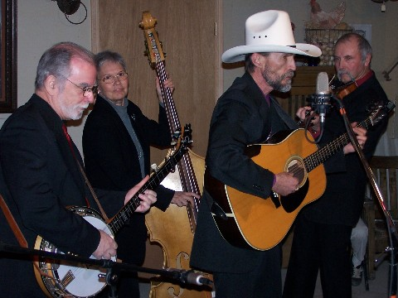
Al Jackson
(All Photos by Jim McCue)



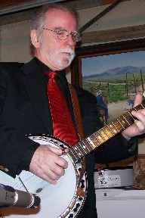

Donna Bond Mike Bond Rue Frisbee

The Final Performance of
The Buckhorn Mountain Boys
Friday Night, April 11, 2008, 6-9pm @The Winery at Eagle Knoll, Emmett
Admission is FREE....no cover Come on out to see us for one last Bluegrass Blowout
The Ten Jammandments

I - THOU SHALT TUNE THINE INSTRUMENT.
There are too many good, cheap tuners around not to do this.

II - THOU SHALT LISTEN
If you can’t hear the lead instrument or vocalist, then consider yourself too loud. If everyone paid attention to this, we could all work more on our tone than our power and volume.

III - THOU SHALT COMMUNICATE WHO HAS THE NEXT SOLO
When handing off an instrument break, try to follow a pattern, either clockwise or counter-clockwise, around the circle. If you want to skip the next solo, or want to pass it off to the next picker, be sure that the next person is aware of the hand-off. No one wants to start a solo in the middle of the song.

IV - THOU SHALT WELCOME OTHERS
Open the circle if other players wish to join. Jam sessions will not be too large if everyone is polite. (Refer to JAMMANDMENT I)

V - THOU SHALT SHARE THE SELECTION
Open the choice of songs to the pickers around the circle. Take turns. Don’t monopolize the jam by playing one song after another.

VI - THOU SHALT TRY NEW STUFF
Once in a while a participant may suggest an original tune or one that is out of character of the jam. This is OK occasionally. (Refer to JAMMANDMENT II & IV)

VII - THOU SHALT LET OTHERS KNOW WHEN YOU ARE NOT JAMMING
Bands may sometimes be rehearsing and may need to exclude non-band members from playing. If so, an explanation would be polite.

VIII - THOU SHALT NOT RAID
Don’t interrupt an active jam by calling favorite musicians away to begin another jam. After a reasonable amount of time, any jam session will change participants.

IX - THOU SHALT KEEPETH THY RHYTHM STEADYTH
Errors in rhythm are the most difficult to overcome. Avoid adding or dropping a beat. Play quietly if you can’t keep up and pay attention. (Refer to JAMMANDMENT II)

X - THOU SHALT NOT SPEED
Do not start a song too fast for the other players. Once everyone has had a turn at the lead, then one may announce that the tempo is about to increase.

By Robert Rosenburg.

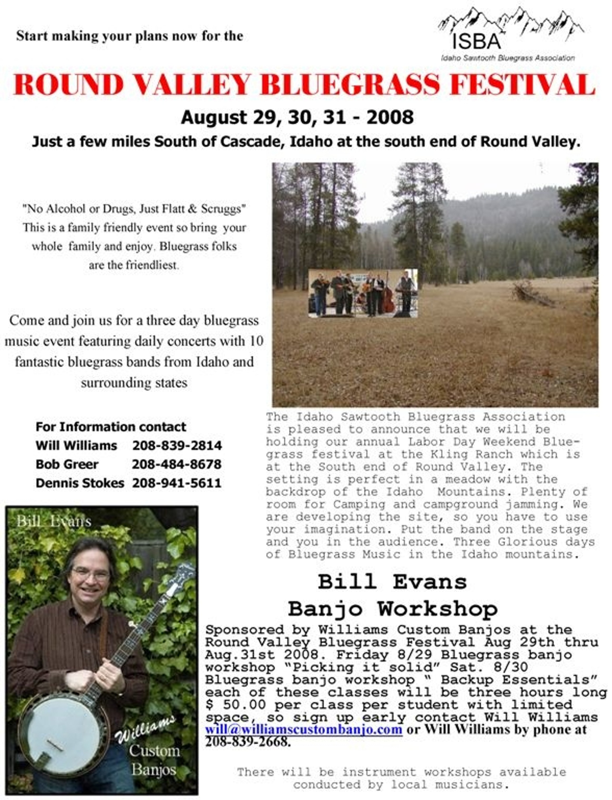

Application for ISBA Membership

Name________________________________________________________________

Address______________________________________________________________

City____________________________ State________________ Zip_______________

Phone___________________________ Email Address___________________________

IdaGrass, the ISBA newsletter is offered either in email or printed letter format. Using email saves the Association
the cost of postage and printing. HOWEVER, because we want you to enjoy and look forward to the newsletter,
we want you to receive the newsletter in a format with which you are comfortable.

I would like to receive the newsletter □ Email □ US Postal Service

□ New Member □ Renewal

Date_____________________

Yearly membership: □$10/individual □ $15/family

Please mail to: Idaho Sawtooth Bluegrass Association
PO Box 123 White Bird, ID 83554

If you have Ideas, Comments, Questions, or Concerns

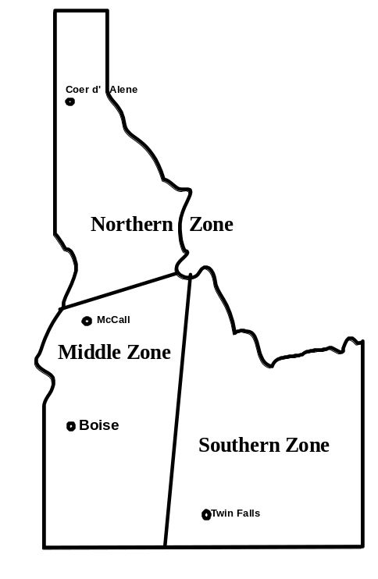
ISBA President

Bob Greer: bobggreer@msn.com
208-466-1719

Northern Zone

Steve Gleason: 208-798-8280

Pete Northcutt: pnorthcutt@mtida.net

Southern Zone

John Boyer: 208-733-4552
boyerj1@mindspring.com

Middle Zone

Bill Elmer: 208-466-1349
mandobil@mail2Musician.com

Bob Greer: bobggreer@msn.com
208-466-1719

Al Jackson: Bmbbluegrass@aol.com

2926 Sugarcane Dr. Nampa, ID 83687

Board Chairman

Will Williams: will@williamscustombanjos.com

Webmaster

Carolyn Johnson: cthorse@gmail.com

Membership

Melba Walker: grandmacooper41@peoplepc.com
208-322-7640

IdaGrass Editor:

Helen Smith: trueblue@wildblue.net

