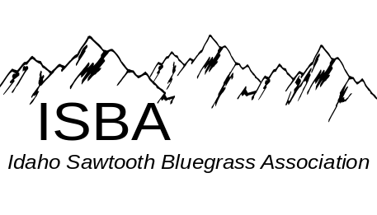
IdaGrass
Volume 2 Issue 3 May-June 2006

Inside this Issue:

Disc Space...………………………page 3

IdaGrass Calendar…….…………..page 1

Idaho Band Dates………………....page 7

In the Spotlight……………………page 9

Message from the Chairman….......page 2

News from the Zones……….....….page 6

Some of our favorite Websites

Montana Rockies Bluegrass Assoc.
www.mrba.com

Universuty of Idaho Bluegrass Club
http://stuorgs.uidaho.edu/~bluegrass/

If you have calendar events, jams or festivals you would like included in the next issue of Ida-Grass, please email them to trueblue@wildblue.net

Many thanks to those who have contributed photos and article to IdaGrass ☺
IdaGrass Events Calendar

May 13, SAT Northern Zone Jam, at The Orchards United Methodist Church, 1213 Burrell Ave. Lewiston Orchards. Jam times1 p.m. to 9 P.M. or whenever Supper break about 5 P.M. Furnish your own meal.
Middle Zone Jam, at the Bob Greer’s Bluegrass Barn, 1822 W Orchard Ave, Nampa, Idaho – 7 pm.
June 10 & 11 Camp N Jam at Dworshak, see page 8

Attention, Attention… All ISBA Members
At the General Membership Meeting, held April 22nd at White Bird Idaho, it was suggested that a list of ISBA members and their email and/or phone number be published in the newsletter, as to assist fellow bluegrassers to connect with others in their area and throughout the state. Recognizing that some members may not wish to have their names published, we are posting this notice. If you do not want your name listed on the ISBA General Membership List, please contact Helen before June 30th
Helen Smith
1556 Stites Rd
Grangeville, ID 83530
(208)983-7910
trueblue@wildblue.net

The purpose of the Idaho Sawtooth Bluegrass Association:
- To preserve and perpetuate Bluegrass music as a heritage of our country,
- To promote the education and the enjoyment of Bluegrass music,
- To promote fellowship among all musicians and supporters who have a love for Bluegrass music, regardless of race, creed, color, ethnicity, or ability to play music.

Message from the Chairman
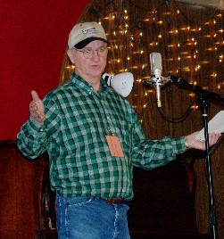
Photo by Jim McCue

Hello to all ISBA Members:
I hope everyone is enjoying spring as it is here and summer is fast coming on. Summer is going to be very busy with all the opportunities to be with friends and play some of that good old Bluegrass music. I hope you calendar is loaded with good thing for you and yours. I would like to start by thinking everyone who made the trip to Hoot’s for the Spring Super Jam/three day festival. It was a wonderful time enjoyed by all. The jams I listened to were at every level, from beginner to very hot. Thank you also very much to all of the ISBA Bands that gave of there time and money to support this annual event- The Grangeville Bluegrass Company, Liver City, Hotwire, Mike and Tari Conroy & Heavenbound. They all did an outstanding job on stage for the 300+ people from around the area. Many favorable comments have been made to members of the association and to Hooty, of Hoot’s, that they have never heard any better Bluegrass played anywhere. People kept asking, “Are you going to do this again next year?” Members from the Northern zone worked very hard to put this on and the turn out was their thanks.
Now on to other things. A committee has been formed for getting together another event of this kind of this year around the first of second weekend of October, after the IBMA – for those who are going to Nashville. It will be in the town of Payette, we will keep members informed on this as it comes together. Our membership has now grown to 58 singe and 24 family memberships. I expect this to even get larger after the Payette event. The jams in each zone are going on a regular basis now and even some campouts planned. This is very good as the work gets out, we will do what this association has planned to do – spread bluegrass throughout the state of Idaho. We are asking for nominees for ISBA President. If you know of someone that can love the people, bluegrass music and is willing to give of his or her time and travel some, please submit the name to: wanab@starband.net. We will have a general vote before the 31st of December. There are several events around the state this summer. Let’s all talk up the ISBA to people that would be interested. Members, if you have an event in your zone, let’s make sure we have an ISBA table there and people there to work, if at all possible. Have a happy summer.
Your friend, Will Williams.
Keep on Pickin’

Cole Mandolin
1055 South Adell Ave,
Filer, ID 83328 (208) 326-5224
E-Mail: ron@colemandolins.com

Stop by the Cole Mandolins Booth at the
Father’s Day Festival at Grass Valley in June

Beautiful hand-crafted Mandolins
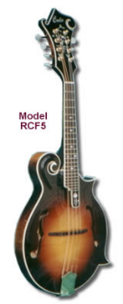

HELP, HELP, HELP……

The ISBA desires to get a website up and going. If you would be willing and able to help promote bluegrass in this way, please contact – wanab@starband.net

Disc Space by Mike McCarthy
ISBA Member, Mike McCarthy lives in Twin Falls and thinks “you can never have too much banjo.” Mike has agreed to share review newly released and other CDs with our IdaGrass Readers.
“Without Maps or Charts” by Hit and Run
The future of bluegrass is in good hands! Hit and Run is composed of five accomplished musicians who combine a healthy respect for tradition with their own style. The best thing about this group is that the total package is better than the individual parts.
Hit and Run has 3 excellent lead singers - Guitarist Rebbecca Hoggan, bass player Erin Coats, and mandolinist John Frazier. The harmonies are tight and the mixture of male/female voices holds your interest.
Rebecca's flat picking is as impressive as her singing. Erin Coats started playing bass as a child (check out her solo on “Lockdown For Your Love”). John Frazier plays a traditional, Monroe style, but with his own touches. Aaron Youngberg is a Scruggs oriented banjo player who also puts his own stamp on things. Todd Livingston rounds out the group on dobro. The CD as a whole is excellent - well paced, with changes in tempo and style, and really interesting arrangements (what do you expect from a CD produced by Kenny and Amanda Smith).
Erin sings lead on a Fine gospel song called the "Keys to the Kingdom." Rebbecca wrote "Why Does this old Town Look Better Now." I also like the way she sings "Hardwood Floor." There are several traditional songs culled from Hobart Smith, Alan Lomax and Library of Congress recordings. When they do a Stanley Brothers tune they pick one that is less well known - Highway of Regret. These guys are also great live and I highly recommend seeing them and picking up this CD.
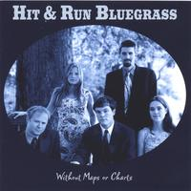

Application for ISBA Membership
Name________________________________________________________________
Adresss______________________________________________________________
City_______________________________State________________ Zip___________
Phone_______________________ Email Address______________________________
IdaGrass, the ISBA newsletter is offered either in email or printed letter format. Using email saves the association the cost of postage and printing, HOWEVER, because we want you to enjoy and look forward to the newsletter, we want you to receive the newsletter in a format with which you are comfortable.

I would like to receive the newsletter Email__________ US Postal Service__________

Yearly membership - $10/individual $15/family
Please mail to: Idaho Sawtooth Bluegrass Association
PO Box 123 White Bird, ID 83554

Spring Super Jam 2006 @ Hoot’s in White Bird
A great big “Thanks” the Idaho Bands who gave a great performance

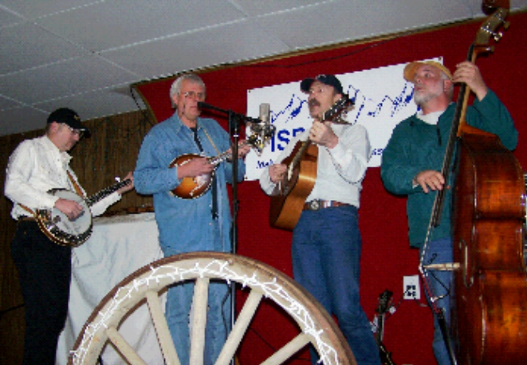
Hotwire Photo by Jim McCue

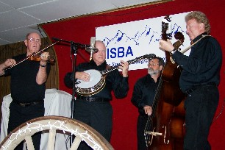
Silver City Photo by Jim McCue

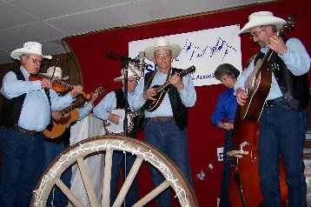
Grangeville Bluegrass Company
Photo by Jim McCue
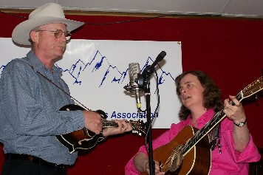
Mike & Tari Conroy
Photo by Jim McCue

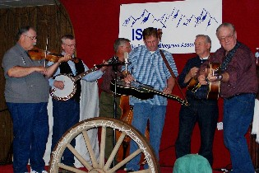
Heavenbound
Photo by Jim McCue
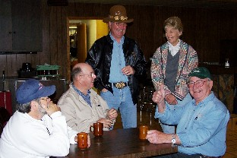

HEaven

Time for chatting
Photo by Jim McCue

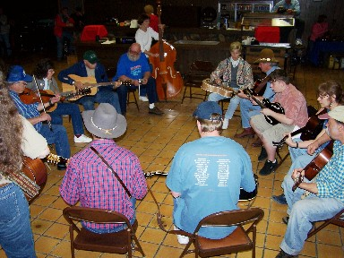
Jamming
Photo by Jim McCue

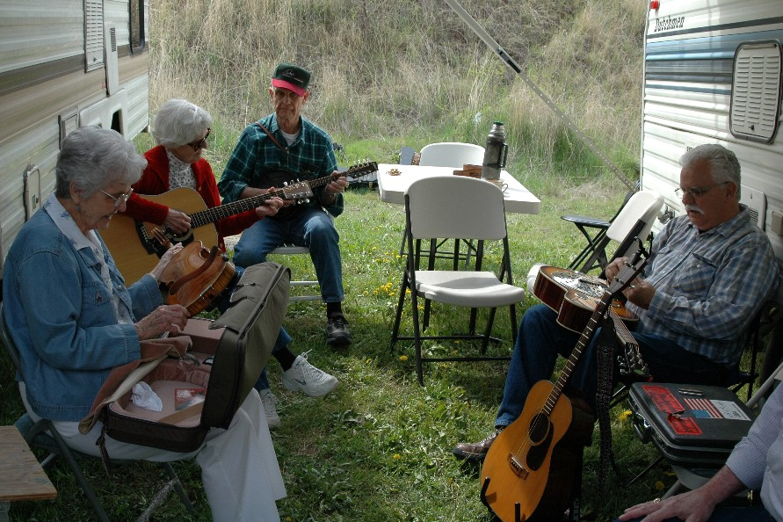
Jamming
Photo by Will Williams

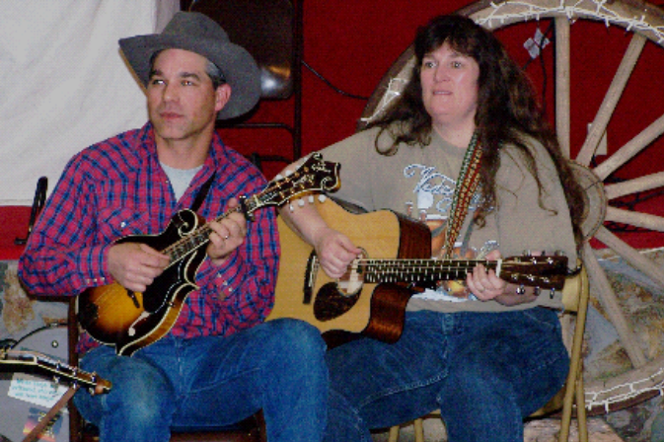
Jamming Photo by Jim McCue

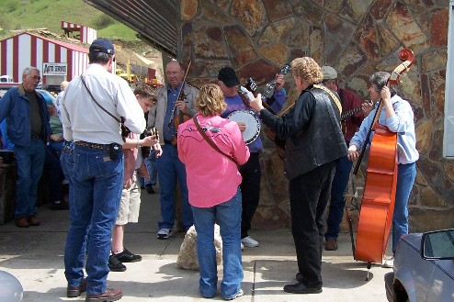
Jamming
Photo by Jim McCue

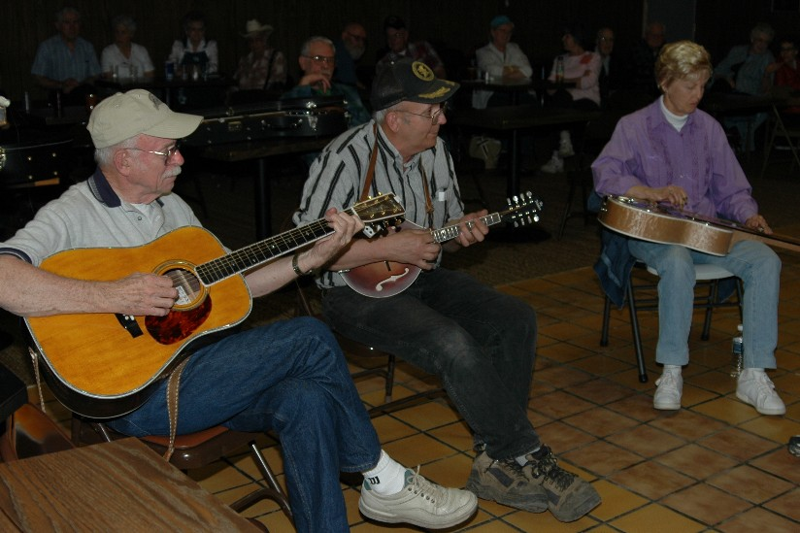
Jamming
Photo by Will Williams

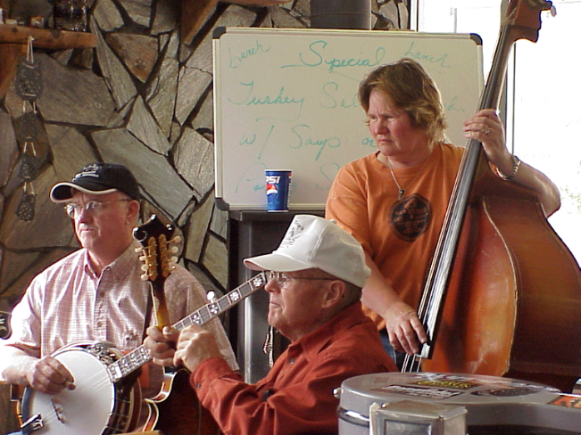
And MORE jamming Photo by Mac McMinn

A new generation of Bluegrassers

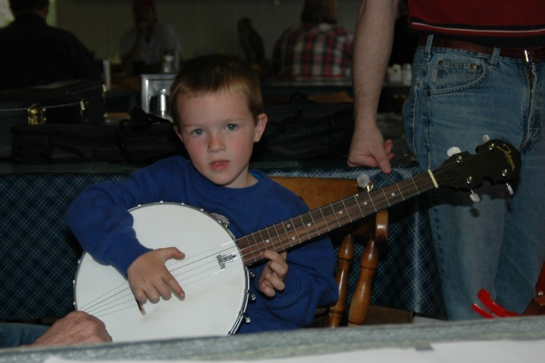
Wyatt Williams
Photo by Helen Smith
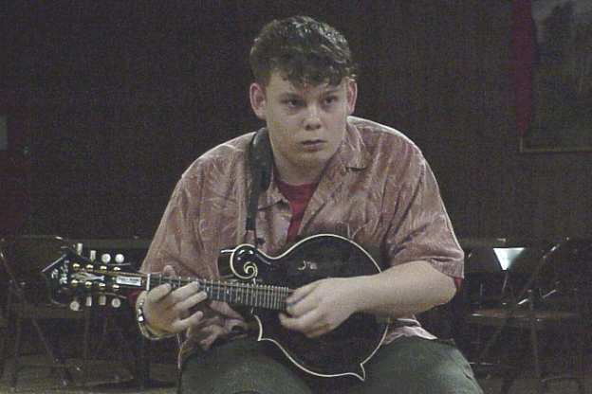
Dakota
Photo by Mac McMinn
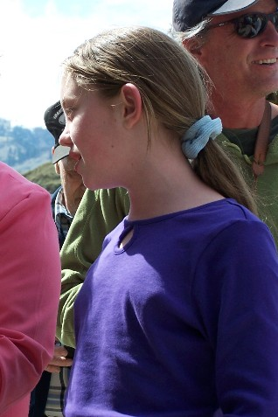
Brandi Photo by Jim McCue

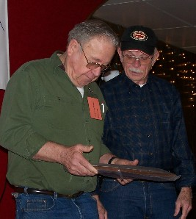
Photo by Jim McCue
A token of appreciation to Bob Greer for all his efforts in
promoting and preserving bluegrass in the state of Idaho
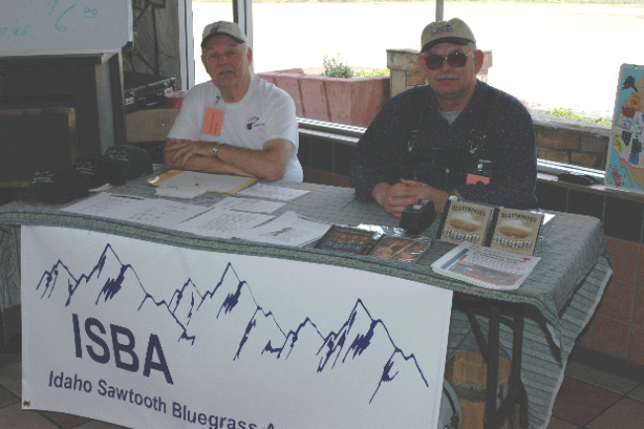
Board Members at Work
Photo by Will Williams

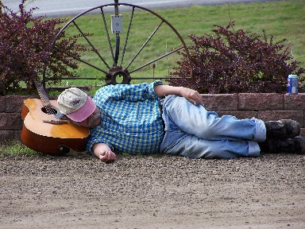
“I am weary, let me rest”
Photo by Jim McCue

News from the Zones
Northern Zone
The March monthly jam at the Orchards Methodist Church in Lewiston on the 1st of april went well. About ten musicians and ten listeners showed for the event.
It was pouring rain out so was a good place to be on such a damp day. The music was plentyfull and enjoyed by all. Some new tunes and new players, remembering some old tunes.
We played till almost 5pm. Steve and Gail now have the key to open up and Kristy and AJ will be coming up in near future more infromation on more jams. This musician sure enjoyed the jam as missed the last one. Because of everyones help and willingness to do, we as a group enjoy being together. Looking forward to more music, Carol Gregg

June Camp N’ Jam at Dworshak
We've set a date for our first Bluegrass Only
Dworshak Campin'Jam at Freeman Creek
RV Park at Dworshak Lake (above Orofino) –
the weekend of June 10th and 11th.
If you are planning to attend, please contact Kristie Stevens, fellow bluegrasser and manager at Dworshak - kstephens@idpr.state.id.us
Kristie will have directions available for those of you who don't know how to get there. We plan to have potluck supper Saturday evening and lots of
fun pickin' and grinnin'! If you have any
questions or suggestions to add to the planning
and the fun please contact either Kristie at the
above email address or myself at
ajbarnett@nwinfo.net
Thanks and keep smiling - folks will wonder what you're up to! Till next time, AJ

Other Bluegrass Happenings

Memorial Weekend Campout
Mike and Tari Conroy's annual memorial weekend
campout is again scheduled for may 26-29..we will
(as always) have heated wall tents for jammin...it
is again at the Little Westfork campground, a
forest service campground with no charge, it is a
beautiful place with an outhouse and creek right
next to it..lots of room for big rigs to park.it
is on the edge of the selway wilderness..great
hiking, biking, 4 wheeling etc...the campground is
aprox 23 miles south of darby mt.(50 miles south
of hamilton)---- head south out of darby and take
the westfork highway. go 14 miles up the west fork
highway and turn right (just past 14 mile marker)
on the nez perce rd ...go 4 miles and turn right
at end of pavement... campground is on the
right..potluck dinners at 6 pm on sat and sunday
and monday morning conroy's furnish and biscuits
and gravy breakfast at 10 am...all bluegrass
lover's welcome!!! ya'll come! for more info
call mike or tari at 1-406-821-3777 or email
Tariconroy@webtv.net

Camp And Jam in Sandpoint
Come pick a little bluegrass with your friends at the Bonner Co Fairgrounds, Sandpoint, ID. Beginning WED, July 19th through SUN noon, July 23rd.
The fee for camping is $10.00/night, payable to the Bonner Co Fairgrounds
Potluck supper: TH 5:45. Please bering food, table service and beverages. A short meeting held before the meal
Band Scramble: SAT Check registration table for more information.
Gospel Jam: SUN 9:00 am
For questions/more information:
Herman & Gail Waldron
PO Box 475
Pomeroy, WA 99347
(509)843-1404

Gilmore Days 2006, August 4-6th
Sponsored by Doyle Hammon Family,
(208)390-1083
FRIDAY
6pm – Dutch Oven Potluck
7pm – Open Mic Stage and Campfire Sing-a-long
SATURDAY
Breaskfst, potluck. Join us at the lodge
Kid’s Activites: nature hike, doll house, games, etc
Music Workshops: Banjo, Guitar, Mando & Fiddle
Country Store: Antique Museum, Silent Auction
Lunch – on your own
3 pm til bedtime – Open Mic
Photo Gallery – bring your camera, we have props, costumes, and backdrops
Guided Tour of the Ghost town and Cemetery
SUNDAY
10am–Non-denominal Service and Gospel Music
Dry Camping ONLY, No Smoking or Alcohol
Entrance Fee – Bring something for the silent auction
60 Miles So of Salmon, near Gilmore Summit

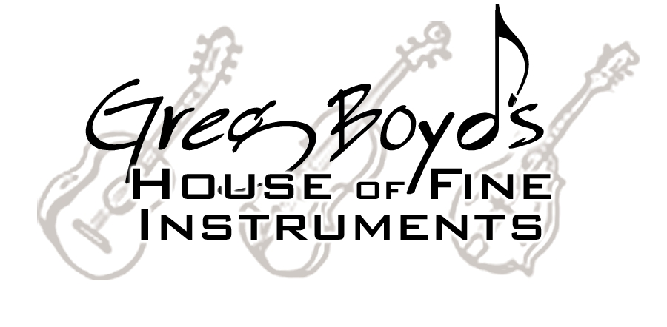

311 Knowles St - Missoula, MT 59801 - 406/327-9925

One of America’s Premier Bluegrass Stores

Guitar Strings $5 - Mandolin Strings $5 - Banjo Strings $4 EVERYDAY

Always offering the best in Vintage & Handmade
Acoustic Instruments & Professional Accessories

Weber / Collings / Bourgeois / Prucha / Noble
Beard / National / Rayco / Lebeda
Used & Vintage Martins and Gibsons

A nice gift anytime. . . . . . . . .



…available mailed OR e-mailed to recipient…

Straps / Cases / Gig Bags / Calton Cases / Capos
Strings / The right Picks / Stands / Books / DVD’s
Tuners / Metronomes / T-shirts

Come visit our website

www.gregboyd.com

And when in Missoula, stop by our store:
Mon-Thur 10-6 Fri 10-5 Sat 10-4

Low Internet prices

In the Spotlight with
Hotwire
Interviews with Idaho’s Bluegrass bands

I first had the pleasure of hearing Hotwire play at the ISBA sponsored Spring Super Jam in White Bird. I was especially impressed with their hard drivin’ and the quality of their instrumental playing. I contacted Dale and asked they would be willing to be “In the Spotlight”, and so here we are - Helen :-)

Question: Tell how us about how you came to play together and how long.
In the summer of 2005 we threw together a bluegrass band to perform at the McCall Summer Music Festival. The idea was to gather the best musicians in the area. At that time the band had no real name, and was billed as “The Seldom Herd”—a play on newgrass bands “The Seldom Scene” and “Rarely Herd.” After that, we decided to keep the band together and look for jobs.
Question: Band names come in through a variety of processes, how did you decide on Hotwire?
The band members came up with several names, but Hotwire got the most approval. Dale came up with that name because he felt it conveyed energy. He also came up with the tag “High Voltage Bluegrass” that we put on our cards and other publicity.
Question: You all play and are quite accomplished on multiple instruments. Tell me about the benefits and challenges.
Benefits, it adds to variety and versatility, so it’s more interesting for the crowd and for us as well. Dennis says it makes it more fun, too! The only challenge, if it is one, is giving each band member the opportunity to show all their skills, deciding who will play what on a particular song and what combination of instruments will be best for it. We’re still exploring the possibilities—that’s fun.
Question: How do you decide who is going to play what?
We all have our primary instruments, so this is our basic setup on instruments:
Dale is the main singer. Dennis is the only one who plays banjo. Whale plays bass on most songs and sings harmony. Dave is the main flatpicker on guitar and mandolin and is our only real fiddler. He also sings harmony.
We alter that setup depending on whether one of us has a song that he sings well or plays a particular instrument well on. Sometimes we switch around just because it’s a fun change of pace.
Question: Brag on each of your band members a minute. Tell us one about what each brings the band.
Dave is unquestionably the best guitar flatpicker. He constantly leaves us slack-jawed at how good he is. He has a repertoire on that instrument that he has honed over the years that we take advantage of, but he can also improvise incredibly well. The same is true on mandolin. When we try a song that he has never heard, he seems to play almost as well as he does on the ones he has played for years. The rest of us just look at each other, smile and shake our heads.
Dennis is also a really good flatpicker on guitar and mandolin. We feature him on those instruments when we do a song that he has worked out leads on them. Dennis says he can’t sing, and we haven’t put the screws to him on that one… yet.
Whale is our bass man. We’re all capable of playing bass, but not at a professional level. So far we only have a couple songs on which someone other than Whale plays bass. Whale plays mandolin on those at the moment. He also plays guitar and octave mandolin, and we need to work out songs on which he plays those instruments.
Dale has only been playing mandolin seriously for about two or three years. He was always the main singer in any band he’s been in, and didn’t work on his flatpicking skills until fairly recently. He plays mandolin when one is needed and Dave is playing another instrument. He has played fiddle for years, but doesn’t feel proficient enough on it to take a principal lead. He also plays around with the Dobro, so we’ll see what develops there.
Question: You all have had a great deal of experience playing in other bands. Tell me what you each have most enjoyed about playing with Hotwire.
Dale: We’ve been around long enough that can pick up harmonies quickly. Whale: I like being with a strong vocal presence.
Dennis: It’s a challenge to keep up with the other band members.

Dave: We learn songs quickly and have a good vocal blend, and some interesting instrumental arrangements.
Question: What do you see as the biggest challenge for bluegrass bands?
Dale: Getting good (paying) gigs!
Dave: Staying together
!Whale: Exposing those who haven’t heard it before to bluegrass music, and having them like it
Question: What do you each like to do when you are not pickin’ music?
Dennis and Dale are rabid elk bowhunters every September. Whale likes to do a lot of whitewater rafting. Dave has fallen in love with catching steelhead.
Question: Besides having enough gas money to get home from a gig, what are your goals or hopes for the future?
Mo money, mo money, mo money! Seriously, it would be nice to be in demand enough to make good money. I think we’ve all been in the music business long enough to know that “making it big” is a one in a million thing and is an extremely challenging lifestyle if you do get there. I think our goal is to supplement our incomes doing what we love. It might be nice to perform at a festival or two some time.
Question: Do you have plans for a CD? How soon or why not?
We're thinking in that direction, but haven't started working on one yet.
Question: I’d like each of you to name the person who has been most influential in your bluegrass journey.
Whale: Tim O’Brien
Dale: Tim O’Brien
Dennis: Dan Crary
Dave: Doc Watson or Mark O’Connor

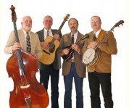
Whale, Dave Hunt, Dale Fisk, &
Dennis Maggard.
Visit Hotwire’s website at:
www.ubl.com/artists/hotwire

- - - - - - - - - - - - - - - - - - - - - - - - - - - - - - - - - - - - - - - - - -

“Professional Banjo's at a price you can afford.”

Williams Custom Banjo

Will Williams
PO Box 123 White Bird, Id 83554
208-839-2814
wanab@starband.net

Come visit us at: www.williamscustombanjos.com
Superior Quality and a sound you will love!

Idaho Bands You can hear great bluegrass all summer long……check out these places and dates
May 13 Heavenbound & Council Mountain Bluegrass Band @ Bluegrass in the Barn – Nampa, ID 7pm

May 19 Grangeville Bluegrass Company Hometown Concert, Grangeville HS 7 pm

May 26 Buckhorn Mountain Boys Donnie Mac’s - Boise, ID 6 pm

May 31 Buckhorn Mountain Boys The Bardenay - Eagle, ID 7pm

June 3 Buckhorn Mountain Boys House Concert - Forest Grove, OR

June 4&6 Buckhorn Mountain Boys Portland Rose Festival - Portland, OR
Waterfront Village 6:30pm & 9:15pm
Waterfront Village 5:00pm & 7:30pm

June 7 Buckhorn Mountain Boys Great Pacific - Pendleton, OR 6 pm

June 10 Heavenbound & Buckhorn Mountain Boys Henny Penny Market (Bluegrass in the Barn) -
Nampa, ID 7 pm

June 7 Buckhorn Mountain Boys Great Pacific - Pendleton, OR 6 pm

June 8 Deadline Ridge Boise Days 2006, Fort Boise Park, Parma, Idaho 7:30 to 9:30 pm

June 21 Buckhorn Mountain Boys The Bardenay - Eagle, ID 7 pm

June 24 Buckhorn Mountain Boys Capitol City Marketplace - Boise, ID 10 am
Donnie Mac’s - Boise, ID 6 pm

July 2 Buckhorn Mountain Boys Reds, Whites & Bluegrass/Ste Chapelle Winery - Caldwell, ID 1pm

July 8&9 Buckhorn Mountain Boys Mountain Music Festival - Battle Mountain, Nevada
Deadline Ridge Mountain Music Festival - Battle Mountain, Nevada

July 12 Buckhorn Mountain Boys The Bardenay - Eagle, ID 7 pm

July 21-23 Buckhorn Mountain Boys Darrington Bluegrass Festival - Darrington, WA
Deadline Ridge Darrington Bluegrass Festival - Darrington, WA

July 22 Heavenbound & Grangeville Bluegrass Company Henny Penny Market (Bluegrass in the Barn) -
Nampa, ID 7 pm

August 3 Buckhorn Mountain Boys Idaho Botanical Gardens - Boise, ID 6 pm

August 12 Deadline Ridge 21st Annual Bowers Mansion Festival - South of Reno, Nevada

August 19 Buckhorn Mountain Boys Foxall Fiddle Fandango - Emmett, ID
Grangeville Bluegrass Company Cancer Camp Benefit - Grangeville, ID

August 23 Buckhorn Mountain Boys The Bardenay - Eagle, ID 7 pm

August 25-27 Buckhorn Mountain Boys Bannock County Bluegrass Festival - Pocatello, ID
Deadline Ridge Bannock County Bluegrass Festival - Pocatello, ID

These dates are just highlights of Idaho band schedules – for complete band listings,
contact the bands or visit their respective websites

