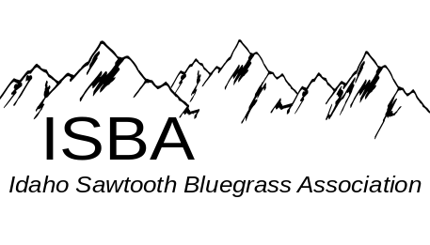
IdaGrass
Volume 2 Issue 2 March - April 2006
Inside this Issue:

Chatting with the Board……….….page 8

Classifieds………………….…….,page 9

Disc Space...………………………page 4

IdaGrass Calendar…….…………..page 1

Idaho Band Dates………………....page 1

In the Spotlight……………………page 6

Message from the Chairman….......page 2

News from the Zones……….....….page 5

Spring Jam Info…………………...page 3

Some of our favorite Websites

Montana Rockies Bluegrass Assoc.
www.mrba.com

Universuty of Idaho Bluegrass Club
http://stuorgs.uidaho.edu/~bluegrass/

IdaGrass Events Calendar

March 11, SAT Middle Zone Jam, at the Bob Greer’s Bluegrass Barn, 1822 W Orchard Ave, Nampa, Idaho – 7 pm.
April 1, SAT Northern Zone Jam, at The Orchards United Methodist Church, 1213 Burrell Ave. Lewiston Orchards. Jam times1 p.m. to 9 P.M. or whenever Supper break about 5 P.M. Furnish your own meal.
April 20, TH Southern Zone Jam, at Gerties’ Brick Oven Cookery in Twin Falls – 7 pm.
April 21- 23 1st Annual Spring Bluegrass Jam, at Hoot’s in
White Bird, ID. For hotel reservations, 208-839-2265

If you have calendar events, jams or festivals you would like included in the next issue of Ida-Grass, please email them to trueblue@wildblue.net

Idaho Bands

3/18 Willow Valley String Band from Cache Valley UT and Heavenbound at the Bluegrass in the Barn, 7 pm (208)
3/25 Grangeville Bluegrass Companys at the Kenworthy in Moscow. More info - www.kenworthy.org
4/15 Public Radio from Hailey ID and Heavenbound
at the Bluegrass in the Barn with 7 pm.
.

The purpose of the Idaho Sawtooth Bluegrass Association:
- To preserve and perpetuate Bluegrass music as a heritage of our country,
- To promote the education and the enjoyment of Bluegrass music,
- To promote fellowship among all musicians and supporters who have a love for Bluegrass music, regardless of race, creed, color, ethnicity, or ability to play music.

Message from the Chairman

Hello Fellow ISBA Members:
Man time sure does fly. It seems I just sent a message the other day.
February has been a hard month for me as I had a knee replacement about four weeks ago.
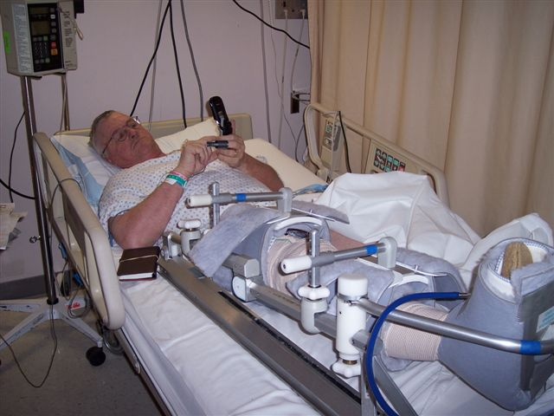
“I may be down, but still on the phone doing ISBA business”

This has slowed me down somewhat. But many members of our fast growing association have been very busy working on building the ISBA to a great Bluegrass concern here in the state of Idaho. Way to go Board Members Steve Gleason and Pete Northcutt for getting a monthly jam started in
Lewiston Idaho on the first Saturday of each month. The very first jam had 30 people show up and many people joined the ISBA. I plan to be at the next one even if I have to set in a chair to pick. This kind of a turn out lets
me know that people are hungry for what we have to offer in a true Bluegrass setting.
Time is moving forward to the ISBA annual Hoots Super Jam on April 21, 22, 23.
" Don't be square be there"
Tell your friends help us make this outing a great success. We have be hearing from people from Montana that are planning
to come over to play some music with us Idaho pickers its going to be a blast don't miss it. You should be able to see more on this event in this issue of Ida Grass. Let us know if you are coming?
We are getting a line up of good pickers and bands that are members of the ISBA. ISBA Board Member Bob Greer and I did a live radio show Friday the 27 of last month with KRLC in Lewiston Idaho. We talk about this association on the air and people are very interested and want to hear more.
If we all work hard we will have the best Bluegrass thing going. We are alarge membership.
We do need some help with someone to handle a web page for us as it is time
for this to happen. So if you can help us out on this please email me at:
wanab@starband.net
People want to know about the ISBA and they need a place they can go and LOOK at us.
I think I need another pain pill so I will stop for now I will see you at Hoot’s .
KEEP ON PICKING and Telling Everyone about the ISBA.

Will Williams

Cole Mandolin
1055 South Adell Ave,
Filer, ID 83328 (208) 326-5224
E-Mail: ron@colemandolins.com

Beautiful hand-crafted Mandolins
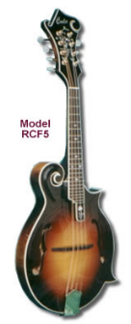

HELP, HELP, HELP……

The ISBA desires to get a website up and going. If you would be willing and able to help promote bluegrass in this way, please contact – wanab@starband.net

Idaho Sawtooth Bluegrass Association
1st Annual Spring Jam
April 21st – 23rd
At Hoot’s in White Bird
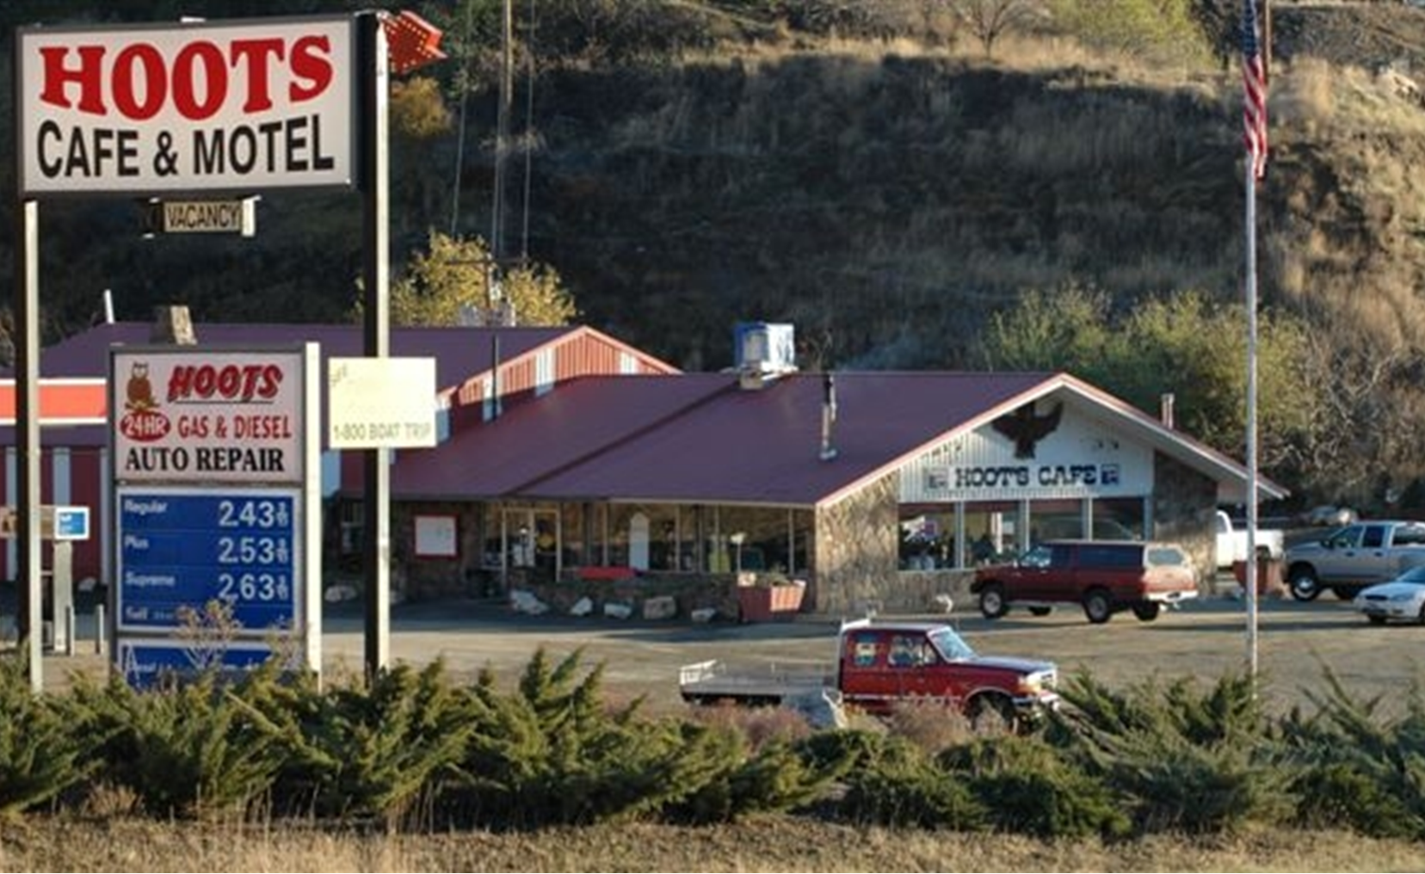
Instrument Sales
Hats,T-shirts, CDs
ISBA Booth
Instrument Workshops

Schedule of Events
Friday, 21st
Open Jam, all Day into the night
Saturday, 22nd
9am Annual ISBA General Meeting,
10:30 Instrument Workshops – Banjo Set-up, Bass, Guitar, Mandolin, Jam Etiquette
12 Noon Open Jam all afternoon
5:30 pm Dinner buffet and Door Prizes.
Buffet served by Hoot’s - Roast Beef, Mashed Potatoes and Gravy, Salads, Dessert, Lasagna, and More
7-9 pm Free Performance of Bluegrass Band
9 pm Open Jam – until we pass out or our fingers fall off, which ever happens first
Sunday 23rd
Open Jam all Day
For RV/Hotel Reservations at Hoot’s call (208) 830-2265
For more information – wanab@starband.net
3 Glorious Days of Bluegrass

Disc Space by Mike McCarthy
ISBA Member, Mike McCarthy lives in Twin Falls and thinks “you can never have too much banjo.” Mike has agreed to share review newly released and other CDs with our IdaGrass Readers.
Last Goodbye by Deadline Ridge
Deadline Ridge "Last Goodbye" - This is the second CD from this Magic Valley group. This CD captures the energy of their live shows. It contains mostly standards, although some are more obscure tunes (like "Somehow Tonight," "Head Over Heels”). The drive comes from the solid bass playing of Ryan Hillier. The title cut "Last Goodbye" is an original from guitarist Rob Harding that could have been written by Hank Williams. Rob also flat picks some fiery leads in his unique style and another fine original. Sean Dean replicates the hot fiddling he delivers live. I particularly like his fills and the way he dives into his breaks. Ron Hillier anchors the band with strong, traditional Scruggs playing. Ron and Rob split the lead singing, and the harmonies are tight. In all, a strong, solid CD from these guys. www.deadlineridge.com

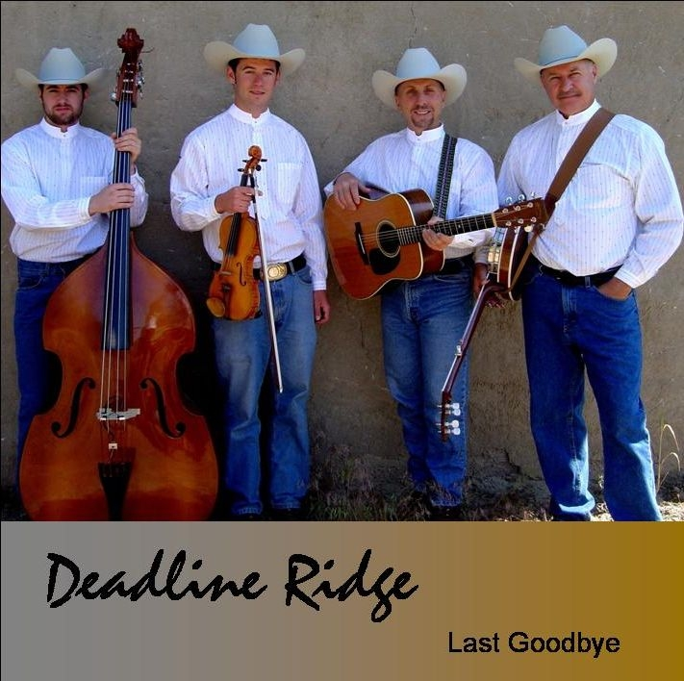
Walk On By by Steam Powered Airplane
Steam Powered Airplane is a Bozeman/Jackson Hole based band (if that’s geographically possible). Their
CD "Walk On By" is definitely rooted in traditional bluegrass. The "mandolin guy" is Uriah Price. His playing and song selections (Doreen, There ain’t Nobody Gonna Miss Me When I'm Gone) show strong traditional bluegrass influences. The bass guy, Cody Walters is the best slap bass player I've ever seen. On banjo, Tucker Smith plays more melodic licks than you hear these days. He's also a fine flat picker and wrote 3 originals. Kester Erickson's voice (Old Train) and fiddle are some of the best parts of the CD, but she did not appear with them live.
She also wrote two originals (including the title cut). The "guitar guy"(didn't catch his name) who replaced her live was a strong flat picker. Live, they played mostly bluegrass, in a "jam grass" style (long renditions and medleys) and more swing oriented tunes than traditional bluegrass people might like, but they were still worth seeing if they play near you. If you want to learn more about this fine group their web site is: www.steampoweredairplane.com
Steam Powered Airplane will be in Ketchum, March 10th and in Boise March 11th.

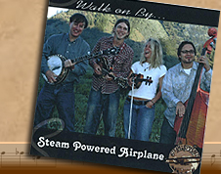

Bands Belonging to the ISBA

- Buckhorn Mountain Boys
www.buckhornmountainboys.com

- Deadline Ridge
www.dealineridge.com

- Grangeville Bluegrass Company
www.grangevillebluegrasscompany.com

- Heavenbound
(208) 466-1719

- Midnight Flyer
(208) 466-1349

Congratulations !
Wahoo!
Good Job !
Buckhorn Mountain Boy’s latest CD, "ONE MORE RIVER", has received considerable airplay from Bluegrass Radio across the country. You can read the reviews the CD has received in Bluegrass Unlimited (Dec 2005) and in Bluegrass Now (Feb 2006) magazines Congratulations BMB!
News from the Zones
Southern Zone by Deb Crawford
ISBA Zone 4 News: We met at Gertie's Pizza in Twin Falls on Thursday Feb.16th and had a great time. It seems word of mouth is really bringing in a lot of interest and quite a few new members. I think I have 2 or 3 more that are wanting to be part of ISBA. How exciting! Lot's of talent in our area with all different skill levels. One of our newest members Cindy Newbry offered her home to hold a bluegrass workshop this Saturday at 6pm. The address is 528 Center St. in Kimberly. 423-5073 is her phone # if anyone is interested in coming and sharing there knowledge. We are hoping to help the members who are just learning bluegrass, so the plan is to help them learn the proper rhythms, breaks and possibly work on some harmony. I'm sure it will probably turn into an all out jam before it's over. Seems to be the way this bluegrass stuff ends up. That's what makes it sooooo.. much fun!! Everyone is supposed to bring some kind of finger food treats to share. So come join us if you can! We will find out at the March 16th jam if everyone wants to hold an April jam or postpone it so those who can make it to Hoot's Cafe wouldn't be missing out on Zone 4. I will try and let you know as soon as I find out. Well guess that's about all for now. Deb
Middle Zone by AJ Barnett
The Northern Region is now having monthly bluegrass jams the first Saturday of each month at the Orchards Methodist Church in Lewiston, Idaho. Any and all bluegrassers or listeners are welcome and encouraged to drop by. Those who made it to our second monthly jam session on March 6, 2006, had a great time pickin' and grinnin' from
1:P.M. until 8:30:P.M. The participants from Kooskia, Grangeville, and Camas Prairie areas had to brave blizzard like conditions to drive down. Now that takes dedication folks and we're mighty proud of them (not to mention they're all good musicians)!
Carol and Rich Gregg have made the big move to the full-time RV life. They've sold their Lenore home and will be living in a nice fifth wheel...look out world here they come! Carol tells me they will soon have a cell phone and a wireless laptop so they can keep in touch with everyone.
Steve Gleason is the very happy and proud owner of a brand new Banjo made especially for him by Will Williams. It has a flat top Huber Tone Ring and Keith De-tuners and also has a speed neck for fast action. It's a beauty and sounds great. He played it for the first time at our Saturday jam.
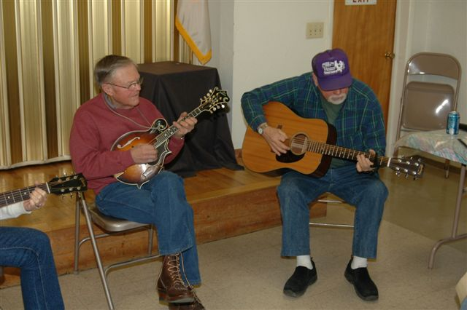
Bass player Kristie Stevens, who is also the Park Manager for the Dworshak Dam Park just out of Orofino, Idaho, brought her two daughters Brenna, age 7, and Morgan, age 13, to the jam. Both girls play the fiddle and did a few tunes with us. Kristie told us that we can have a jam at the Big Eddy Lodge almost anytime this spring. During the summer, she said, some weekends have reservations. She said there are multiple rooms if we need to divide into a few groups (or maybe do some workshops?) Just think folks, playing your favorite kind of music while looking out over the Dworshak Dam. Way Cool! as my grand-children would say! It was suggested at the jam that maybe we could switch the location of the monthly jam, i.e., Orofino or Kamiah vs Lewiston, from time to time so that those living farther out don't always have to drive so far. It was also suggested that we might want to have a very brief, informal business meeting at each jam just to share ideas, and discuss the nitty gritty stuff. So put these things in your thinking caps for our next get together Saturday, April 1 (All Fools Day by the way).
Please contact me at the above email address with any news or information for our monthly Northern Region newsletter report. Don't be bashful, let us know what's going on with you.
Thanks and keep smiling - folks will wonder what you're up to! Till next time, AJ, ajbarnett@nwinfo.net
(Above photo: L to R – Herman Waldron and Rich Gregg. Northern Jam, March 4, 2006)
Middle Zone by Dennis Stokes
Hey ya'll,
I'd like to announce another ISBA (Idaho Sawtooth Bluegrass Association) sanctioned jam at Bob Greer's Barn this Saturday, March 11 at 7pm. You do not have to be an ISBA member to attend, but membership applications will be available. We had a great turnout for the last one and a good time was had by all. All skill levels are welcome, the only requirement being a will to learn and enjoy traditional bluegrass music. In fact, here's a task for this week's jam for everyone. Bring one new song that you love but haven't used in a jam by Flatt and Scruggs. It doesn't matter if you even bring the words to help you. Have one prepared and everyone can enjoy playing along with you. This is a great way to learn a new song. Next jam we'll try another traditional bluegrass artist.
Fellow picker,
Dennis Stokes
In the Spotlight
with
Public Radio
Interviews with Idaho’s Bluegrass bands
“Chip Booth, the bandleader of “Public Radio”, out of Haley Idaho, graciously agreed to tell us about their band.”
Question: Chip, you lived most of you life in South Carolina. In relationship to bluegrass, tell us about the benefits or drawbacks of those years.
I was constantly trained musically through college (and still to these days) and listened to and enjoyed a wide variety of musical styles, but bluegrass was something I never listened to regularly. However in that part of the world you can't help but be exposed to it, and I appreciated the musical virtuosity of the players, even if the sound was too "hillbilly" for my tastes at the time. I did enjoy other types of folk music though, and while spending a couple of years playing in Atlanta, Georgia I started to really take notice of the Bluegrass scene and began to buy records. By the time I moved to Idaho I was a fan. I realized I knew more about the sound of Bluegrass than I ever would have imaged, learned mostly by osmosis, just from being around it in the South.
Question: You have played the guitar, bass and mandolin. What instrument is your favorite?
Guitar is my first love, and if I had to choose only one instrument that night be it, due mainly to the fact that it is so versatile. However, these days my guitar tends to sit unused while I play the mandolin. The sound can be delicate and soothing, or it can bark like a dog. When I am unable to play anything for a few days at a time it is the mandolin I miss the most.
Question: Have you ever considered learning banjo?
I do play banjo, on several tunes with the group.
Question: Speaking of the formation of "Public Radio" you said, "the chemistry ways good". Tell us how you feel about the importance of good chemistry.
I can't say enough about the chemistry in a band. Over the years I have played with many great players that I had no real connection with, and good music just doesn't come out of that. One of my most successful groups was a band of above average players, but without anyone who was truly outstanding. We had amazing chemistry though, and the connection on stage was obvious to listeners. Players I highly respected would comment on how good the band was, even if the individuals in the band were not at their level.
Question: Brag on each of your band members a minute. Tell us one specific strength they each bring to benefit the band.
Jeremy: Our bass player comes to us with a jazz background. He is well trained and has an infallible sense of rhythm. We rely on him completely to keep everything together. Although not a singer when he started with us, he has been working at it as hard as he can. You will hear him sing more than ever this year.
Cody: Cody came on as a rhythm guitar player and quickly evolved into so much more. More than any of us he put in the hours at home and he is now picking tunes at light speed, and even learned to play the mandolin on some songs. Cody is our rock, always ready, always dedicated.
Hart: Hart is the guy with the golden voice. Playing and singing comes more naturally to him than anyone I know.
Chip: Chip brings many years of experience in professional groups. His strong point is arranging songs and harmonies for the group. Chip also books the band and tries his best to keep everyone on the same schedule.
Question: Explain the process in which you guys choose a new tune.
We are open to suggestions from anyone in the band. Usually someone will get excited listening to a song and present it to the rest of the guys for consideration. We may all love it right away, or we may let it sit for a while. Sometimes we will try playing a song we all love but realize it isn't right for us. Either it doesn't blend with the other material we are playing, or maybe it doesn't fit our vocal style. In that case we do what is right for the band and let the song go. There have been songs we weren't all crazy about that we added to our set in order to fill it out quickly for a long gig, just because we all knew them. After playing them we discovered that the songs fits us perfectly and they have moved into our standard set.
Question: What is the difference in performing bluegrass in contrast to others kinds of music?
The main thing for me is that Bluegrass is exhausting. I can play a four hour night of rock and roll and not feel as beat up as I do after a one hour set of Bluegrass. The fast pace requires attention every second; you never have a minute to relax. Also, the Bluegrass audience is a smart one. They know their music, and though they are always appreciative they know when you are goofing off or not giving it your all.
Question: What tune do you most enjoy playing as a group?
The band always enjoys “Old Home Place”, it's collectively one of our favorite songs, and one of the first we learned. We often end sets with “Midnight Moonlight”, and our audiences tend to get into the song, sing along, and we all get to stretch out and solo a bit.
Question: What is one of the biggest challenges for "Public Radio"?
Like all bands made of up of people with jobs and families, it is tough just to put in the time. We do a great job of it though; everyone is very dedicated to the band and the music we play. Another uphill battle for us has been that all the members are coming around to Bluegrass later in life, and so we are all learning the style as we go. We've made amazing progress in the last few years, and I think people will see a big difference between this summer and last.

What is one of Public Radio's goals for the future?
Our biggest goal these days is to finish recording a CD. We have been slowly working on it all winter, learning some challenging new songs, and taking our time with the recording process. It's coming along, and we hope to have it ready by late spring. We also hope to expand the area we play this summer, and get out into even more of Idaho and beyond. 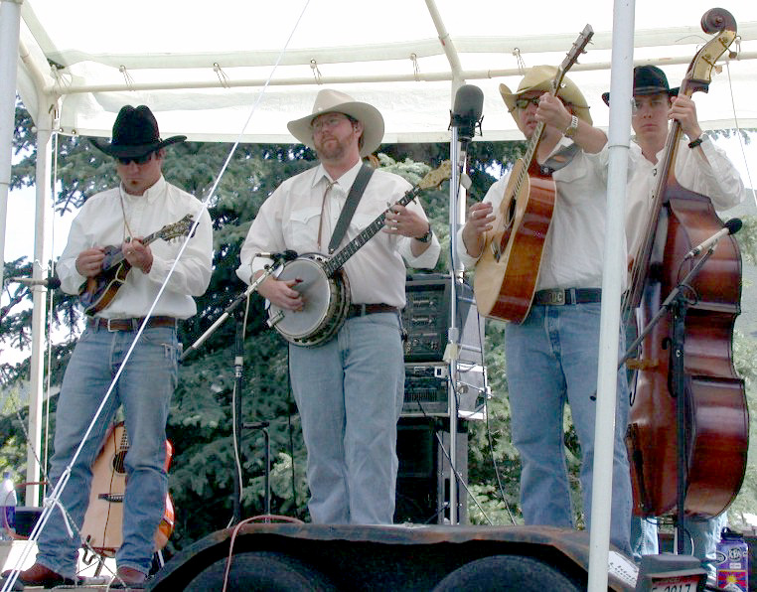“Public Radio”. L to Right – Cody Gibbs, Chip Booth, Hart Gibson, Jeremy Hadden

- - - - - - - - - - - - - - - - - - - - - - - - - - - - - - - - - - - - - - - - - - - - - - - - - - - - - - - -
“Professional Banjo's at a price you can afford.”

Williams Custom Banjo

Will Williams
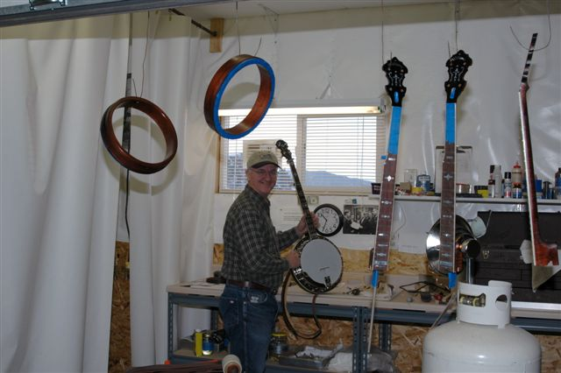
PO Box 123 White Bird, Id 83554
208-839-2814
wanab@starband.net

Come visit us at:

Williams Custom Banjo's
http://my.SpinSite.com/willsbanjo

“Superior Quality and a sound you will love.”

Chatting with the Board
This month’s chat is with Ron Cole,
who is currently serving as a Southern Zone Board Member
Question: What is the most difficult part of playing mandolin?
Some people say the fingerboard and its smaller size and I have to agree that it has its problems sometimes with the fingering but practice helps to overcome that along with the music you play, often it helps to get the feel and presence of the instrument more with practice, to get the string harmony's and tremolo’s again with more practice, the better a person can become.
Question: Was your childhood family musical? Bluegrass?
I have always been playing some kind of instrument since my early days in grade school with the trumpet, drums, trombone in a school band and a concert piano accordion which I played for many years in pre school to jr. high, only then I quit to play football and baseball, and then too there was the girls. My mother begged me to continue as I was going to be in bigger things at the music company called Patti Brothers in Milwaukee, Wis. She said I could be somebody and not be a hardworking laborer like some, but like some kids I didn't listen and quit the
accordion. I also tried the banjo for over a year over a year or so in So. Cal after I got married, faithfully I took lesson's from a good young teacher who knew the instrument in and out, he was very patient with me at that time and because of my work and not practicing like I should have, traveling out of town a lot always to make ends meet I was slack. But that soon became hard to do and I again soon quit that banjo
Question: I have heard the beautiful singing you do with your wife, Barbara. What are some of your favorite songs to do together and why?
My wife Barbara and I have been singing in church for many years with the gospel songs and worship tunes are where its at for her and I but then too its our bluegrass music whether it be gospel or secular grass is our greatest love, to sing for our Lord and do those good down home songs from the heart of bluegrass is our passion. We at times can't seem to get enough of the wonderful music that is out there and to sing with her is what I love the most, we always get closer when we do our duets and stage performances, its so good to be singing with someone you love. The songs we like reflect the harmony's and tunes of the mountain bluegrass, gospel and folk music, the Everly Bros. early songs and the present day church music and hymn's.
Question: You have play mandolin with Heavenbound, a bluegrass gospel band, for about two and a half years. What benefits and challenges have you personally experienced playing with a band?
That's a good question. To sum it up I can say these guys I play with in the band are very good friends, we can really get close and make wonderful music together. You get a feel of what each is doing and wanting and at times too there has to be adjustments made to keep in harmony with everyone. All of us love the bluegrass music and we do a fine job with our band and try to make a lot of people happy with the music we do
Question: You have a business related to bluegrass, Cole Mandolin. Tell us how you first got started making mandolins.
I thought I would have liked to make one mandolin for myself after reading a book "how to construct a bluegrass mandolin" by Roger Siminoff and after a few mandolins built, I thought I could always do better and after a few of them I finished up people wanted to buy those. From then on I went to get my own tone wood from the mountains and was on the lookout for good looking curly hardwood like Maple or Walnut. As I kept building mandolins the public were calling and asking about them even more and more and with the trips to the festivals and jam sessions they were getting sold to many of those who played them and tried them out. Today the price has increased and the demand is still good, I am very blessed
Question: Tell us what you think the “perfect mandolin” would be. What kind of wood? Shape? Strings? Etc?
That’s a real hard question to answer. The great mandolin of course is the early Loars of the 20's that's sound most builders search for . Many try hard to get "that early sound" and I too, do my best to have a bluegrass sound on my mandolins that the players want and to give them a beautiful instrument they can be proud of for years to come. My guess would be that the best mandolin out there is what would work for the builder to give
(Continued on page 9)
the customer what he or she wants, the tone they would like and the beauty that they would want, along with the wood that looks great and to play good and smooth, easy going.
Most hardwoods that have fine looking figure and curl usually do well to make a good looking instrument along with a soundboard wood, can give just the right tone and sound that your looking for. There are many woods to choose from these days and a lot of the luthiers are bringing in European stuff and wood from Alaska and South America, anything that has been proven by the other builders to make a quality mandolin will be a winner.
Question: What is the most difficult bluegrass tune you have learned? Why?
My personal hard song was Jerusalem Ridge and Wheelhoss because of the speed it has to go, they are fast and very catchy to be right on, Rawhide is also a good one. Actually a lot of bluegrass tunes are very fast and speedy, that what makes bluegrass so challenging, its a good feeling to complete a fast song along with other people your jamming with and make it sound good, everybody really enjoys a nice peppy bluegrass tune. I've had some trouble with some other songs too which I won't mention but with playing a lot and some help from people on where to go and how it goes, it all comes out right after practicing.
Question: What bluegrass tune do you most enjoy playing? Why?
I'd say Rawhide, Amanda Jewel, Shenandoah Breakdown and all the other breakdown's I can get into. The mandolin also sounds great when playing background behind a touching tear jerking song or for ballads and gospel hymns. The mandolin also is used in keeping a solid rhythm chop for many bluegrass tunes fast and slow.
Question: Have you ever written a bluegrass tune? Tell us about it.
Yes I have and I still do many songs in my head or singing them to myself. I am not as gifted as many writers who can do words with their music but with the playing on my instrument I can usually come up with something that will do good in a jam or parking lot.
Question: What is one of your personal goals related to bluegrass?
Actually to reach as many people as possible with the good sound of bluegrass music, playing in jams and to be as good as the folks think you are when you play for them on a stage performance or jam and what you can do best on your instrument. If I can make someone happy to hear what I can do with my mandolin then I too can be happy knowing I have done a good job in playing for
somebody, when they get blessed, I get blessed.

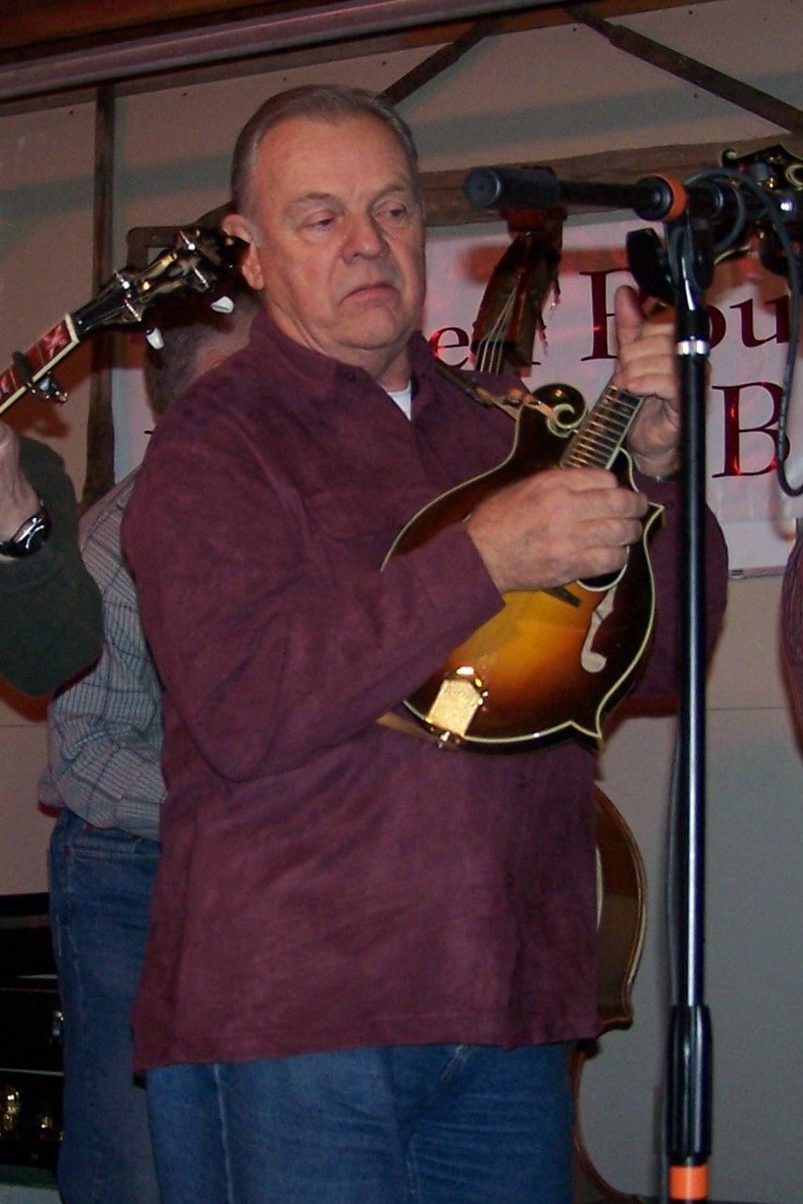

Ron Cole at the Bluegrass Barn in Nampa

IdaGrass Classifieds
Misc: As an ISBA member, you are entitled to one free classified per year. Do you have an unused instrument; give music lessons, looking for a piece of music. Use the ISBA classifieds.
Did you get your free ISBA Bumper Sticker?
They are now mail with the new membership packet. However, if you joined prior to their printing, ask your local board member to find out how to get your ISBA bumper sticker.
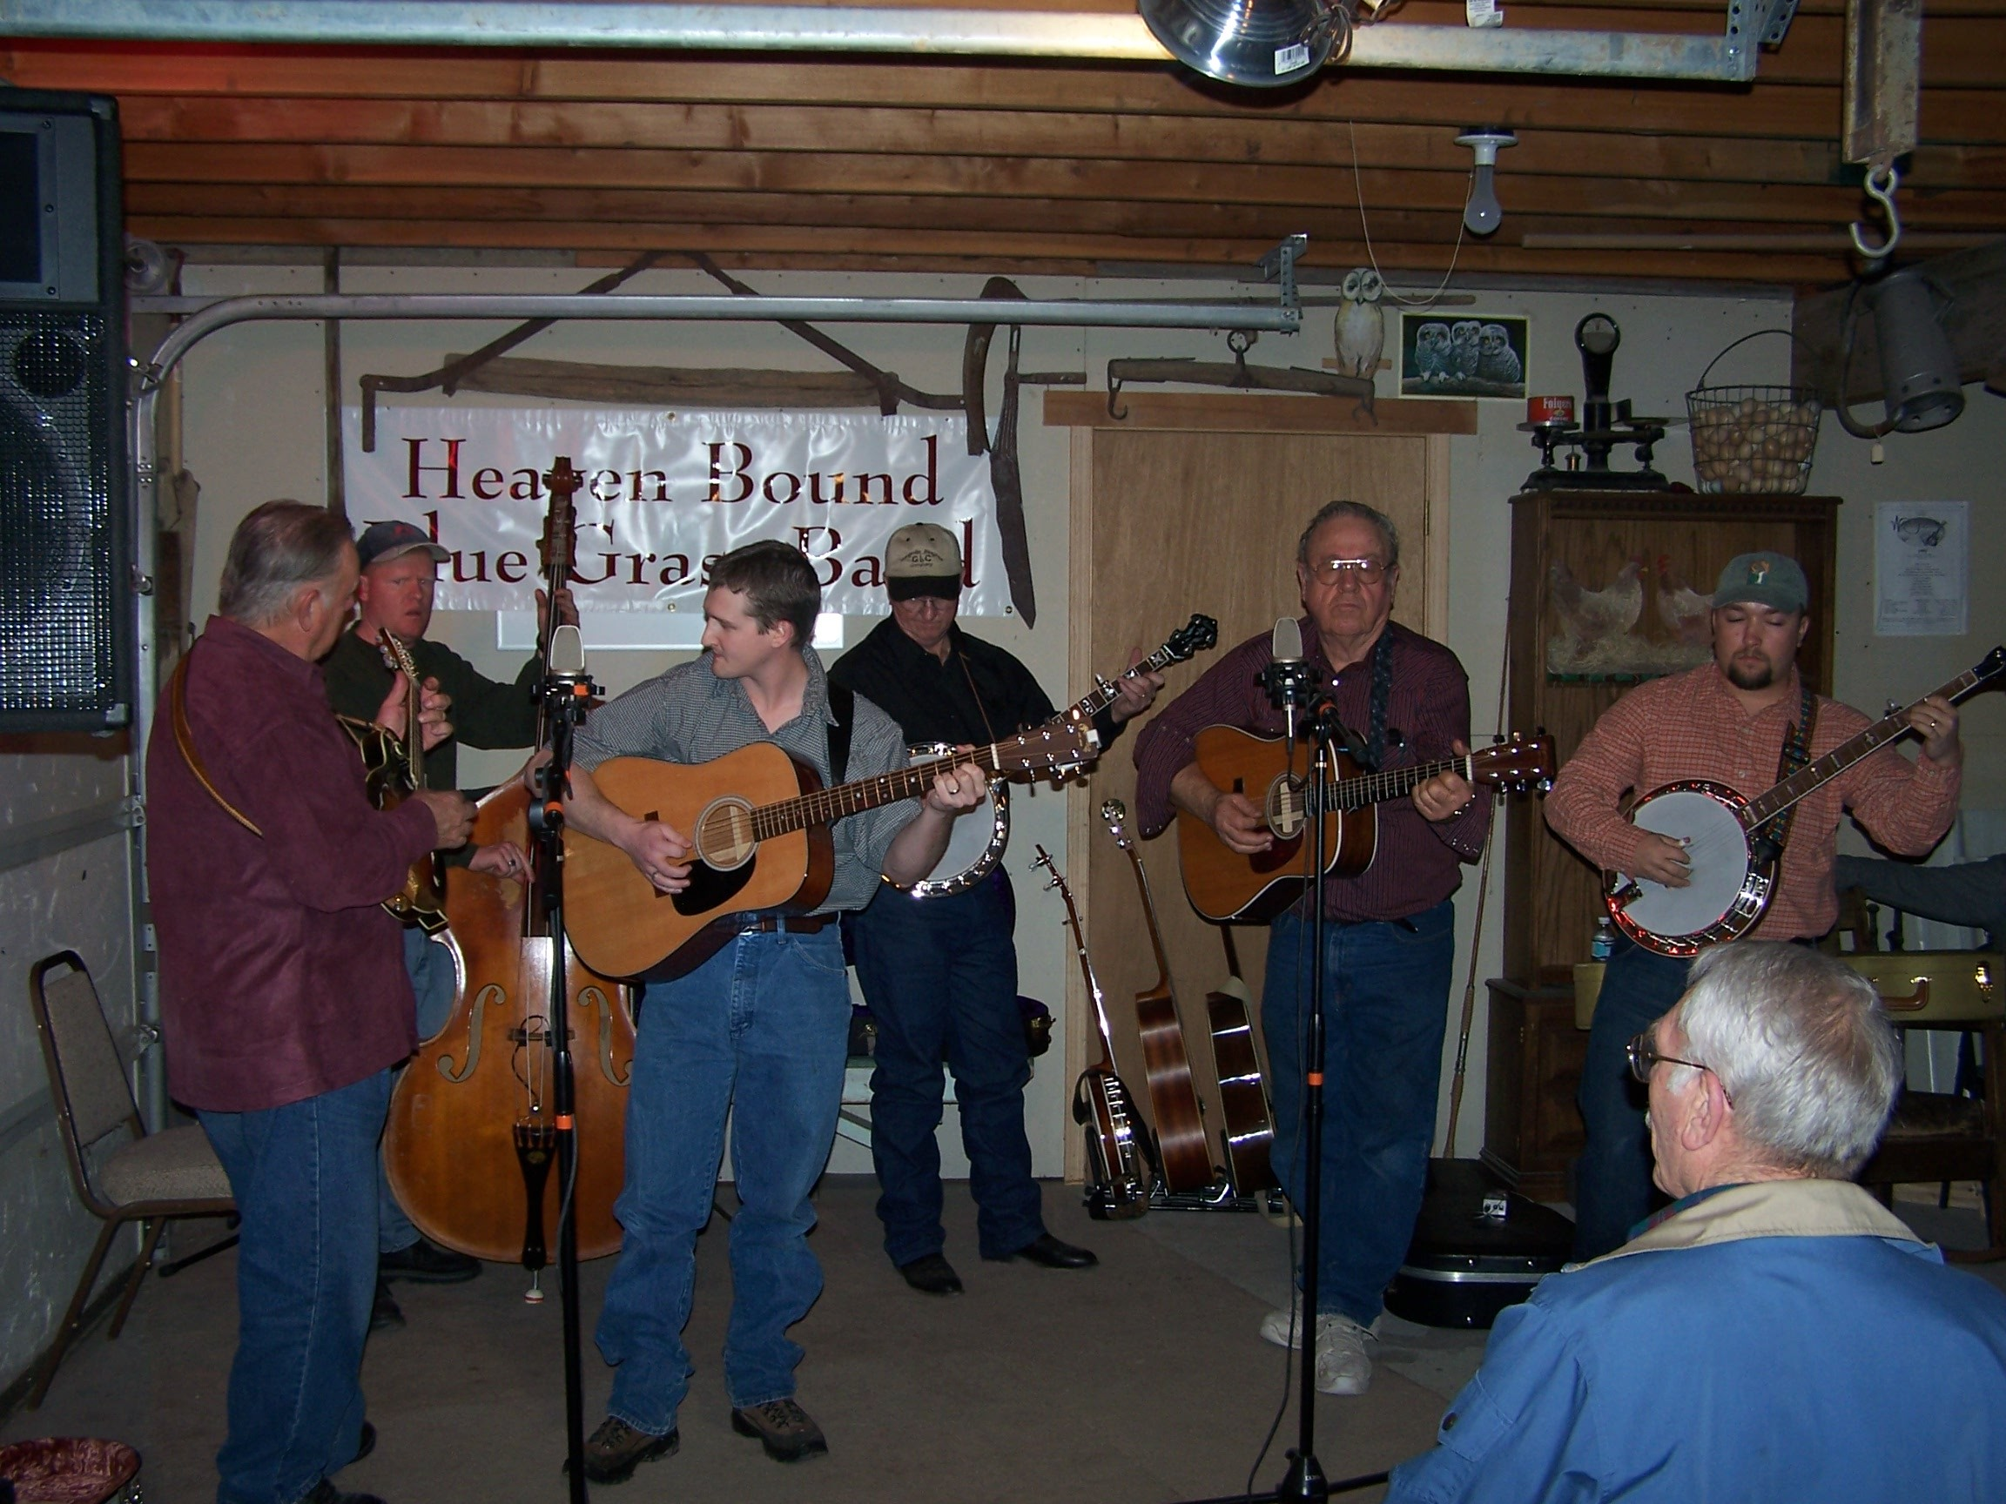
ISBA Members & friends jamming at Bob Greer’s Bluegrass Barn, Feb 06. – Ron Cole, Rudy Corbett, Chris Williams, Will Williams, Bob Greer, John Raptosh) (Photo by Jim McCue)

Application for ISBA Membership

Name________________________________________________________________
Adresss______________________________________________________________
City_______________________________State________________ Zip___________
Phone_______________________ Email Address______________________________
IdaGrass, the ISBA newsletter is offered either in email or printed letter format. Using email saves the association the cost of postage and printing, HOWEVER, because we want you to enjoy and look forward to the newsletter, we want you to receive the newsletter in a format with which you are comfortable.

I would like to receive the newsletter Email__________ US Postal Service__________

Yearly membership - $10/individual $15/family
Please mail to: Idaho Sawtooth Bluegrass Association
PO Box 123 White Bird, ID 83554

- - - - - - - - - - - - - - - - - - - - - - - - - - - - - - - - - -

If you have Ideas, Comments, Questions, or Concerns
your local board member would love to hear from you.

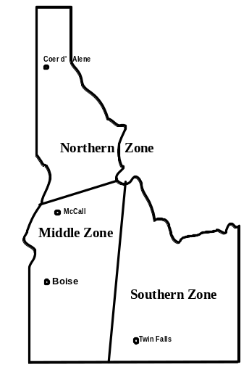
Northern Zone
Steve Gleason: steveng@syringa.net
Pete Northcutt: pnorthcutt@mtida.net
Southern Zone
Ron Cole: colemdln@filertel.com
1055 So. Adell AveFiler, Idaho 83328
Middle Zone
Bob Greer: bgreer15@qwest.net
208-466-1719
Al Jackson: Bmbbluegrass@aol.com
2926 Sugarcane Dr. Nampa, ID. 83687
Board Chariman
Will Williams: wanab@starband.net

