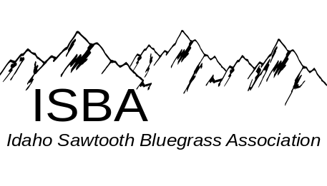
IdaGrass
Volume 2 Issue 1 January-February 2006
Inside this Issue:

Chatting with the Board……….….page 8

Classifieds………………….…….,page 3

IdaGrass Calendar…….…………..page 1

Idaho Band Dates………………....page 1

In the Spotlight……………………page 5

Message from the Chairman….......page 2

News from the Zones……….....….page 8

CD Reviews………………………page 3

Some of our favorite Websites

Montana Rockies Bluegrass Assoc.
www.mrba.com

Grangeville Bluegrass Company
www.grangevillebluegrasscompany.com

Buckhorn Mountain Boys
www.buckhornmountainboys.com

Deadline Ridge
www.deadlineridge.com

Universuty of Idaho Bluegrass Club
http://stuorgs.uidaho.edu/~bluegrass/

IdaGrass Events Calendar

Feb 4, SAT Northern Zone Jam, at The Orchards United Methodist Church, 1213 Burrell Ave. Lewiston Orchards. Jam times1 p.m. to 9 P.M. or whenever Supper break about 5 P.M. Furnish your own meal.
Feb 16, TH Southern Zone Jam, at Gerties’ Brick Oven Cookery inTwin Falls – 7 pm.
Mar 16, TH Southern Zone Jam, at Gerties’ Brick Oven Cookery in Twin Falls – 7 pm.
April 21- 23 1st Annual Spring Bluegrass Jam, at Hoot’s in
White Bird, ID. For hotel reservations, 208-839-2265

If you have calendar events, jams or festivals you would like included in the next issue of Ida-Grass, please email them to trueblue@camasnet.com

Idaho Bands
2/ 24 Grangeville Bluegrass Company & Heavenbound at the Opera House in Kooskia, 7:30pm For tickets call 208-926-0094
2/ Heavenbound and Bona Fide at the Bluegrass Barn featuring
Info/Tickets: bgreer15@qwest.net (208)466-1719
3/25 Grangeville Bluegrass Companys at the Kenworthy in Moscow.
.

The purpose of the Idaho Sawtooth Bluegrass Association:
- To preserve and perpetuate Bluegrass music as a heritage of our country,
- To promote the education and the enjoyment of Bluegrass music,
- To promote fellowship among all musicians and supporters who have a love for Bluegrass music, regardless of race, creed, color, ethnicity, or ability to play music.

Message from the Chairman

Hello fellow ISBA members.

I hope this message finds you all well, that Santa was very good to your household over Christmas, and that the New Year is starting off well for you. It was going good for me, but I just spilled Coke on my computer! I don't see any smoke, the screen is still on, so
I guess I'm ok.
Now back to business. I'm looking forward for 2006 as the ISBA keeps moving forward as a association that you can be proud of. I just attended a board meeting with Ron Cole, Al Jackson, Bob Greer, Pete Northcutt and Steve Gleason this past Saturday in Nampa Idaho. Starting off the year will be our annual Spring Super Jam at Hoots Cafe in White Bird Id. April 21, 22 and 23rd. We are planning a get together that you will remember and will look forward to each year. So put it on your calendar; flyers coming soon.
We have been getting some talk from our friends from the IBA and I think there is plenty of room for both associations in the state of Idaho. Any member of the IBA, which I'm one myself, is welcome to any of our events with open arms and I'm sure some of us will attend their events also, because we love bluegrass music. Now if you have a need that we as an association can help you with please let me know. We are here to serve the best we can this is your association.
Local ISBA jams have been happening in Twin Falls and Nampa over the past few months with a good strong attendance and new members joining each time. This is great, keep up the good work. Steve Gleason, Pete Northcutt, and I have been busy trying to open up the northern part of the state. We have a good base of pickers in Moscow and Lewiston and are holding our first jam in Lewiston on Feb. 4th; times and place listed on the IdaGrass Calendar. Come on by lets pick.
Please let me know if there is an event where the ISBA needs to be with our booth. We can sign-up new member or just to let people know who we are. We would like to know of these events.
I guess I could go on and on but the Ida Grass News Letter might get to long if I'm long winded. Just a quick note, our ISBA Bumper Stickers are in. You get one free with your membership. We do not want to mail them so when you see a board member or an ISBA jam leader, ask for yours. I would just like to close by thanking everyone that came out to see the Grangeville Bluegrass Company perform at the Bluegrass Barn last Saturday night in Nampa. You always make it a fun time for us and make it worth the trip down.

Keep on Pickin’. See you all
Will Williams

1st Annual Spring Bluegrass Jam
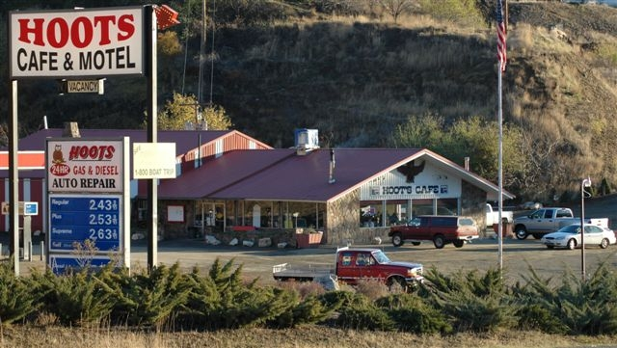

April 21, 22 & 23
@ Hoot’s, White Bird, ID.
- ISBA Annual Meeting
- 3 Glorious Days of Bluegrass
- Motel, RV spots, food and banquet room - For RV/hotel reservations, Call: 208-839-2265
- Open to all, sponsored by the ISBA

CD REVIEWS by Mike McCarthy
ISBA Member, Mike McCarthy lives in Twin Falls and thinks “you can never have too much banjo.” Mike has agreed to share his opinion about newly released and other CDs with our IdaGrass Readers.

Marble town by Blue Highway
If you are reading this you need to buy this CD. Blue Highway combines a respect for traditional bluegrass with contemporary songwriting and arrangements. It starts with the hard driving, bluesy Marbletown, which sounds like it could have been written by Merle Travis.
It ends with the fastest tune I've heard in along time, the Endless Train. In between there's a great new gospel tune (Lazarus) and a great new instrumental (Three Finger Jack - another tune at the speed of light). There's a murder ballad, a Wild Bill Hickock ballad, a geographical cheating song (Tears Fell on Missouri), and a parade song. There are a couple tunes that are too close to country for my taste, but I definitely recommend this one

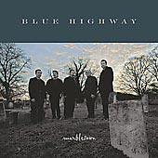

Michale Cleveland/Tam Adams
“Live at the Ragged Edge”
This was last year's instrumental CD of the year. I usually get bored with all instrumental albums, but this one held my interest (caution: I am a banjo player). This is a good source for definitive versions of some standards (Fireball Mail, John Hardy, Dear Old Dixie). Tom Adams can play straight Scruggs stuff as well as anyone. There are a few interesting slow tunes (Box Elder Beetles, Funky Mountain Breakdown). He sings and plays a little, mandolin. Michael Cleveland’s fiddling amazes me. He seems able to improvise something without any effort. Overall worth the money.

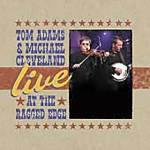

Cornbread Nation by Tim O'Brien
Hard core bluegrass fans will only like a couple songs on this CD. They are very good tunes, done very well: Walking Boss, House of the Rising Sun, and Running Out Of Memory For You. But, I think strict bluegrass people will be disappointed with the rest of this CD. There are good old time tunes: Lets Go Huntin’ and Cornbread Nation. There are some interesting gospel type tunes. If you enjoy Tim O Brien's eclectic style, where he mixes gospel, old time, Celtic, then you will probably like this CD. I don't think it’s as accessible to bluegrass people as the Traveler CD which was more Old Time/Celtic flavored.

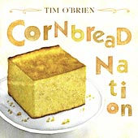
- - - - - - - - - - - - - - - - - -

IdaGrass Classifieds
Wanted: Someone willing and able to organize and maintain a website for the ISBA. If interested or for more info email; wanab@starband.net

Misc: As an ISBA member, you are entitled to one free classified per year. Do you have an unused instrument; give music lessons, looking for a piece of music. Use the ISBA classifieds.

Did you get your free ISBA Bumper Sticker?
Read the Message from the Chairman (page 2) to find out how.


IdaGrass offers regular advertisement space for businesses, bands, individuals:
- $5.00/business card,
- 10.00/quarter page,
- 20.00/ half page,
- 40.00/full page.

“Professional Banjo's at a price you can afford.”

Williams Custom Banjo

Check out these great Banjos -
- 1928 Vintage Prewar Gibson TB2 Conversion Flat head Huber tone ring $3500.00
- 1968 Vintage RB 100 Gibson. $700.00
- Williams Grangeville Pro (New ) $ 2695.00
- Williams Grangeville Pro Demo $ 1850.00
- Williams Custom Walnut Pro Demo $1850.00
- Williams Custom and Lewiston Models to be ready in about 6 weeks

Will Williams
PO Box 123 White Bird, Id 83554
208-839-2814
wanab@starband.net

“Superior Quality and a sound you will love!”

Come visit us at
Williams Custom Banjo's - http://my.SpinSite.com/willsbanjo

About the middle of every month we spruce up the barn,
put a log in the stove, and invite everyone to come and enjoy
an evening of acoustic bluegrass music”

Bluegrass in the Barn

1822 W Orchard Ave, Nampa, Idaho
We feature
- The best local and regional Bluegrass Bands
- Open Mic if you would like to join in the fun
(acoustic bluegrass only of course).
- Gospel and Traditional Bluegrass
Contact the Barnmaster for more information or to get on the email list –
Email: bgreer15@qwest.net
Write: 807 Bonner Place, Nampa, Id 836

In the Spotlight
with
Buckhorn Mountain Boys
Interviews with Idaho’s Bluegrass bands
“This month, Al Jackson of the Buckhorn Mountain Boys was gracious enough to share some of his thought about bluegrass music and their band.” Helen Smith

Question: The BMB were originally organized in OR in 1976. The current players have been together since 2002, the exception of Donna who joined them on bass and vocals in 2003. When you consider all the components of having a successful band, what is the most challenging piece? What is the most enjoyable part?
The biggest challenge to having a successful bluegrass band (or any band) is having people that are all on the same page musically and socially. Everybody has to be able to get along with each other and work out any disagreements. Communication between all band members is essential and everybody has to have the same goals in mind. Fortunately for us, we all have the same goals and in many ways we are more like a family than a band. Also doing all of the work that is involved as far as the business is concerned. You have to be your own manager, booking agent, etc. Fortunately for us, we have my wife Kathy who does our bookings and manages us on the road and sells our merchandise for us. She is definitely the unsung hero in our group and we wouldn’t be as successful as we have been without her work and commitment to the band. The most enjoyable part is being able to achieve the goals that we set and of course actually performing for appreciative audiences. One of our biggest thrills is when people ask us where we are from. Of course we say we’re from Idaho. Then they say…no what part of Tennessee or Kentucky are you from? We really get a kick out of that.
Question: What was one of your most enjoyable performance and why?
We have been fortunate to be able to play and even headline at several bluegrass festivals throughout the west but our most enjoyable performance had to be opening for the Del McCoury Band at the Egyptian Theater in Boise a couple of years ago. We got to spend some time and visit with Del and the boys and talk a little shop but most of all, the audience that night was just on fire. We really feed off of the energy we get from our audiences and that night was electrifying. We received a standing ovation and came back for an encore. That usually doesn’t happen to an opening act. We ranked that show as a 10 and since then we’ve had several 9s but not another 10.
Question: In what ways has your professional background in radio benefited your experience in bluegrass?
My background in radio has really benefited us in regards to how we do business. When you have a band, like it or not, you have a business and you need to run it and treat it as such (that’s why they call it the music business). By being in radio, I got to experience first hand how artists promote and market themselves and get airplay on the radio, etc. I have also worked as a freelance music business consultant and have practiced what I preach. Your band is your product and like any product, folks aren’t going to buy it unless they know about it. Promotion and marketing are essential in have a successful band.
Question: Donna Bond is your bass player and does some vocals. Tell me the strengths she brings as one of the “buckhorn mountain boys”. As a bass player, Donna is one of the best that I know of in the business. The bass, I feel, is the most important instrument in any band and in bluegrass music; you have to have a bass that drives the rest of the band. There’s a lot more to it than just playing the beat notes and staying in time. A driving bass should play just a hair ahead of the beat without speeding up the song. (continued on page 7)

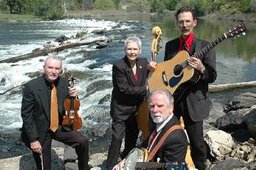
The Buckhorn Mountain Boys, (L to R) Rue Frisbee, Donna Bond, Mike Bond Al Jackson

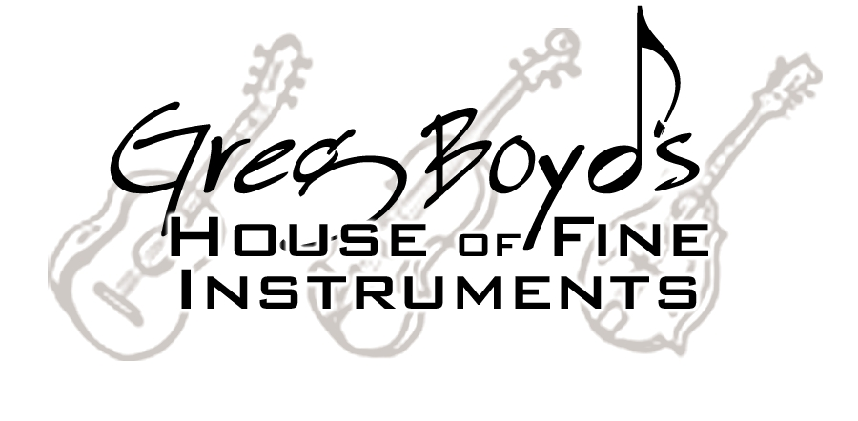

311 Knowles St - Missoula, MT 59801 - 406/327-9925

One of America’s Premier Bluegrass Stores

Guitar Strings $5 - Mandolin Strings $5 - Banjo Strings $4 EVERYDAY

Always offering the best in Vintage & Handmade
Acoustic Instruments & Professional Accessories

Weber / Collings / Bourgeois / Prucha / Noble
Beard / National / Rayco / Lebeda
Used & Vintage Martins and Gibsons

A nice gift anytime. . . . . . . . .


…available mailed OR e-mailed to recipient…

Straps / Cases / Gig Bags / Calton Cases / Capos
Strings / The right Picks / Stands / Books / DVD’s
Tuners / Metronomes / T-shirts

Come visit our website

www.gregboyd.com

And when in Missoula, stop by our store:
Mon-Thur 10-6 Fri 10-5 Sat 10-4

Low Internet prices

Of course everybody else needs to listen closely to the bass and what it’s doing.
When we play a song and the banjo or fiddle takes a break I’m usually listening to the bass and nothing else. A good bass player is the foundation of any band and Donna is one of the best. Vocally, her high baritone harmony gives us a distinct sound. While most bands will have the baritone harmony below the lead vocals, Donna will sing that same part but put it above the lead and tenor harmony. It really makes for a high lonesome sound.
Question: You play guitar and mandolin. Rue plays fiddle and guitar. What are some of the considerations in deciding whether to use fiddle or mandolin in a tune?
Well first of all let me say that Rue Frisbee is one of the finest bluegrass fiddle players around. He cut his teeth on old time fiddle playing but adds a lot of improvisation to what he does with the band. That’s something that I thinks separates old time fiddle players from bluegrass fiddle players, the ability to be able to improvise. In deciding whether to use fiddle or mandolin…the fiddle is one of our primary instruments so we use it on most of the songs we play. The mandolin is used mostly to give us some variety in what we do on stage and we also use it primarily for rhythm on our recordings to give them that bluegrass chop. If I bring a song to the band that I feel like playing mandolin on, then we usually will use the mandolin.
Question: Tell us a little about Mike and the kind of banjo playing he brings to the BMB.
Mike started playing banjo when he and Donna first moved to Idaho in 1972 and he played in some of the very first bluegrass bands in the state. I think I could best describe his playing as being selective. In other words, knowing when to play and when not to play. If you listen closely to a lot of bluegrass recordings you’ll hear that the banjo isn’t playing lead all the time. The sound of the banjo is always present but not always playing lead or fill-ins. I’d say Mike’s banjo playing is more about quality than quantity.
Question: Tell us about the process in which the band decides upon new material.
Usually someone in the band will suggest a song and of course it has to be something that we all like and feel comfortable with. Again it’s more about quality than quantity. Another thing we try to do is to not listen to previous recordings of the song if it’s a cover. That way we are able to do our own arrangement of the song and in a certain way, make it our own.
Question: What percentage of the music you play is original? And do any of the band members write/compose original tunes for the band to do?
Very little of the music we play is original (something written by a band member) however we do a lot of songs that are written by other people that we know. Any bluegrass band has to do a certain amount of traditional bluegrass cover songs but you also have to do a good number of other songs. This is how a band develops its own style and sound. On our latest CD, only 3 songs are covers with the rest being songs written by regional songwriters but never recorded in a bluegrass style.
Question: The BMB have released 3 CDs. The newest one, “One More River” received a very favorable review in Bluegrass Unlimited, December issue. What is your favorite song from the newest CD and why?
I guess I would have to say I’m partial to “Blow Wyoming Blow”. It’s a song that I co-wrote about 12 years ago but not as a bluegrass song. We recorded it on our first CD in 2003 but without harmony vocals. On our latest CD we added the harmonies and Pat Massie played Dobro on the cut which really added a lot to it. That song is also being released nationally to bluegrass radio this month.
Question: From my experience with the BMB, you promote the band using the benefits of today’s technology; emailing up-coming show dates to fans, selling CDs on-line, and a website containing schedules, photos, and clips of music. What are some of both the pros and cons using today’s technology?
The pro’s of using today’s technology is that you can get more information to more people in less time spending less money. I wish that they had PCs and the internet 30 years ago when I started playing bluegrass. The con’s are that first of all one has to take the time to constantly update web sites, press kits, etc. Mike and I were talking about this question the other day and he said another con was that, you have to have it. In other words, the technology, if you want to be successful. I cannot tell you how invaluable having a web site has been and it’s been well worth every penny that we’ve put into it. In my band workshops that I conduct, I tell people that the most important tool any band can have is a PC and a web site. It’s an absolute must.

Chatting with the Board
This month’s chat is with Steve Gleason,
who is currently serving as a
Northern Zone Board Member
Question: Tell us how you first were introduced and got involved with bluegrass.
I was introduced to bluegrass when I was young. My parents and my relatives, had blue grass jams all the time, but professionally, they played country. That is what was popular at that time. I didn't get involved with bluegrass until just a few years ago!
Question: Tell us about the best bluegrass event you ever attended.
I don’t have a “best blue grass event”, they were all great, and a lot of fun.
Question: You play banjo. How long have you been playing?
I have been trying to learn the banjo for about seven years.
Question: What is the most difficult/challenging part of being a banjo player?
My right hand.
Question: I know that your wife Gail plays bass. What are the pros and cons of having your spouse play an instrument too?
The pro is that we practice together and learn together. Can't really think of a con, it has been a plus.
Question: You are an Idaho native, being born and raised in Orofino. Over the years have you seen changes in bluegrass in Idaho?
Yes I have! I have seen, more and more people playing bluegrass and not just older people, but a lot of younger people also.
Question: What are some of your favorite bluegrass tunes and why?
Foggy Mountain Top, Foggy Mountain Breakdown, just to mention a few. They are somewhat challenging.
Question: What is the most difficult bluegrass tune you have learned and why?
Foggy Mountain Breakdown, is a difficult song, only because every one that plays it, plays it different, as far as technique. So I do the song the best way I can.
Question: Personally, what hopes/goals do you have in relationship to bluegrass?
My goal, when I retire, is to attend as many festivals as possible, and learn to sing, while playing the banjo, which I find difficult don't have problem while playing my guitar.
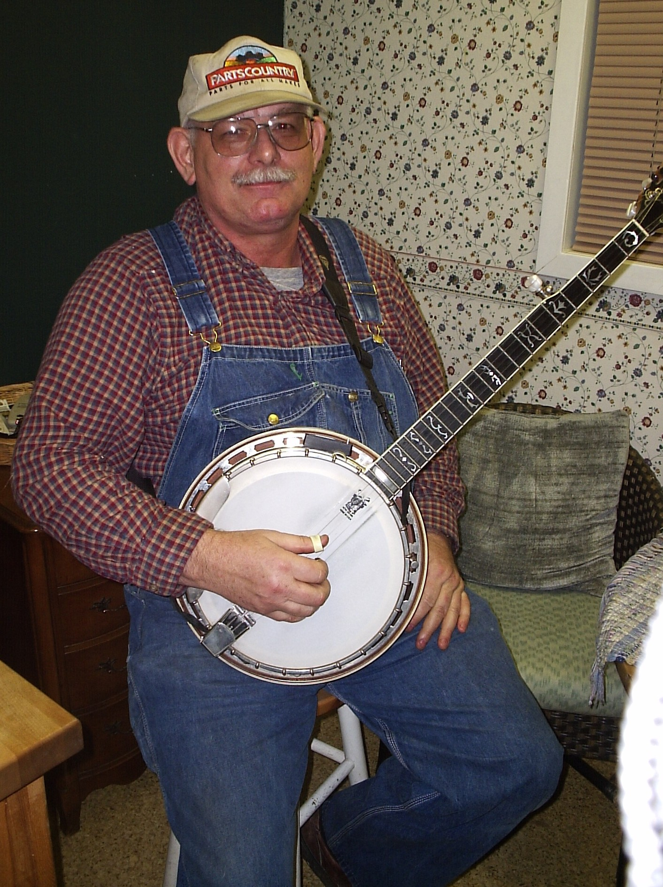

Steve lives with his wife, Gail in Lewiston, ID and works at the U of I in Moscow

News from the Zones
From the Southern Zone by Deb Crawford
We met on January 19th at Gertie's Pizza in Twin Falls and I was truly pleased to see our numbers had grown by half again as many as our last meeting in November. There seems to be LOTS of banjo pickers in our area, so we will have to work on recruiting some more fiddle, guitar and mandolin players. But we do have (3) young people who are doing very well on the fiddle & mandolin. How exciting to see the young folks having a love for bluegrass.
Ron Cole (Mandolin for Heaven Bound & a committee member for the State ISBA) presented our zone with a beautiful ISBA banner that we can display at all our functions and get togethers. We had a short meeting and Ron Cole & Debbie Crawford informed all present just what the ISBA in our zone is hoping to accomplish. Ron Cole and Ron Hilliar (Deadline Ridge) both made themselves available for questions regarding what makes bluegrass, bluegrass and what separates it from other styles of music.(this was done for us beginners and it truly was a great help). After the short meeting everyone had a fun time of jamming, with lot's of pauses along the way to lend a helping hand to beginning bluegrass musicians. I have high hopes and a very good feeling that lots of great things are going to be happening in our zone in the near future. So if you pickers from the other zones are in our area on the 3rd Thursday of the month, be sure and stop by Gertie's Brick Oven Cookery on 2nd Ave. E. in Twin Falls, Idaho. Come and eat some terrific pizza at 6p.m., and then join in our meeting and jams at 7p.m.

Application for ISBA Membership

Name________________________________________________________________
Adresss______________________________________________________________
City_______________________________State________________ Zip___________
Phone_______________________ Email Address______________________________
IdaGrass, the ISBA newsletter is offered either in email or printed letter format. Using email saves the association the cost of postage and printing, HOWEVER, because we want you to enjoy and look forward to the newsletter, we want you to receive the newsletter in a format with which you are comfortable.

I would like to receive the newsletter Email__________ US Postal Service__________

Yearly membership - $10/individual $15/family
Please mail to: Idaho Sawtooth Bluegrass Association
PO Box 123 White Bird, ID 83554

- - - - - - - - - - - - - - - - - - - - - - - - - - - - - - - - - -

If you have Ideas, Comments, Questions, or Concerns
your local board member would love to hear from you.

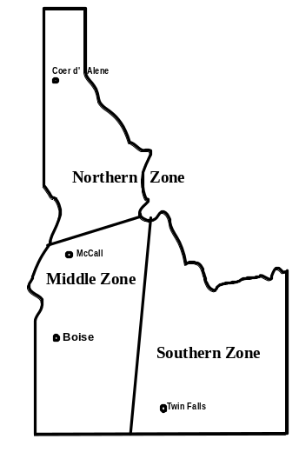
Northern Zone
Steve Gleason: steveng@syringa.net
Pete Northcutt: pnorthcutt@valint.net
Southern Zone
Ron Cole: colemdln@filertel.com
1055 So. Adell AveFiler, Idaho 83328
Middle Zone
Bob Greer: bgreer15@qwest.net
208-466-1719
Al Jackson: Bmbbluegrass@aol.com
2926 Sugarcane Dr. Nampa, ID. 83687
Board Chariman
Will Williams: wanab@starband.net

