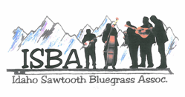

**IdaGrass**

Volume 7 Issue 1 January - February 2011

**Inside this Issue:**

**Application for Membership . . . . . . . 6**

**Contribution from the Board . . . . . . .5**

**From the Editor’s Desk . . . . . . . . . . . 2**

**History of Bluegrass . . . . . . . . . . . . . 3**

**Message from the President . . . . . . . 2**

**Shakin’ off the Winter Blues . . . . . . . 4**

**Bluegrass Calendar**

**February 4/FRI - Chicken Dinner Road**  - Season's Bistro, Eagle ID. 6:30 pm. Tickets: (208) 926-0094

**February 24 – 27th – Wintergrass -** Hyatt Regency Bellvue WA. www.acousticsound.org

**April 16 – Valley Bluegrass Stage** - Clarkston HS., 7pm. Tickets, $5.00 Contact: cleardotlombard@gorge.net

**April 16, 2011 – MRBA 12th Annual Oldtime Bluegrass Festival** - Lone Rock School, Stevensville MT. Noon ‘til 10pm. 16 bands. www.mtbluegrass.com (calendar link)

**May 13- 15, 2011 - ISBA Spring Super Jam**

Lewis Clark Resort, Kamiah, ID. www.idahosawtoothbluegrass.org

**July 22 – 24th – Hardtimes Bluegrass Festival –** Hamilton MT. www.hardtimesbluegrass.com

**August 5 – 7th – Fraser Park Camp & Jam –** Orofino ID. Contact: sgbanjo@hotmail.com

**August 19 – 21 – Council Mountain Music Festival** –

Council ID. www.councilfestival.com

**ISBA Sponsored Jams**

**Boise** – 1st & 3rd TH, 7 pm - 5712 Centerbrook Dr. Intermediate jam, (208) 377-5326 for more info

**Lewiston** –

1st Saturday @ Orchards United Methodist Church, 1213 Burrell Ave

3rd Saturday @ Highlander Community Room,

616 Warner, Steve Gleason

208-798-8280

The purpose of the Idaho Sawtooth Bluegrass Association:

* To preserve and perpetuate Bluegrass music as a heritage of our country;
* To promote the education and enjoyment of Bluegrass music;
* To promote fellowship among all musicians and supporters who have a love for Bluegrass music, regardless of race, creed, color, ethnicity, or ability to play music.

**Message from the President**

From the Editor’s Desk

Greetings and Happy New Year !

I can hardly believe that it is the New Year and that IdaGrass is beginning its seventh year. The New Year is a natural time for change. As you read through this issue of IdaGrass, you will find some new features and I am very excited about them. Starting this month, we are beginning a series of articles called “History of Bluegrass”, written by Nora McCarty. This series will explore the beginning and development of bluegrass into the musical genre we know today. Each issue this year will also feature a submission from one of our board members. They contribute in many ways to the ISBA, but in “Contributions from the Board”, you will be able to read either something they have written or something written by someone else that they feel is of value. This column, “From the Editor’s Desk, will also become a regular feature, in which I may highlight particular features or give a little of my own opinion. I hope you will enjoy these new offerings, and as always, if you have suggestions or contributions you would like to make, just drop me an email.

So, here’s a little of my own opinion ☺

As is common in our culture, the New Year brings is a time for goals and resolutions for improvement in different areas of our lives. When I think about the musical part of my life, experience has taught me that one of the best opportunities for improvement comes when we play music with others. If you want to improve your skill on your instrument, I would invite you to “**Play music with others on a regular basis”**. Depending on your individual commitments to family and work and your location, “regular” will look different for each person, but regular means making a plan. Choose a recurring time slot, maybe once a month, maybe once a week. Even if it’s a couple weeks out, make some phone calls and write it on the calendar. “With Others” can be one person or several. Don’t’ wait for “them” to invite you, be pro-active. You make the plan to get-together. If you want to organize a jam, but are unable, for whatever reason, to hold it at your house, find a free public meeting room at the library or a school.

We can practice at home for many hours, but some of the greatest improvement AND enjoyment occurs when we stretch outside of our comfort zones to interact and play music with others.

Be well & keep pickin’,

Helen

**Message from the President**



*“The position of ISBA president is currently vacant, as Carolyn Johnson has completed her two year term. Until a new president is elected, the ISBA board will facilitate association functions. If you are interested in serving in this position or need more information, please contact Will Williams who is taking nominations.”*

**History of Bluegrass**: An Overview and Series Introduction

By Nora Killion

When I first deliberated writing an article on the history of Bluegrass for the ISBA, I wasn’t sure that anything I had to say would be new or refreshing until I read the purpose of the Idaho Sawtooth Bluegrass Association; to preserve and perpetuate Bluegrass music as a heritage of our country. It is, you know. If America is the melting pot of humanity, then bluegrass is the melting pot of music.

First take the instruments, traditionally; Banjo (African), Fiddle (Irish), Mandolin (Italian). Now add the Guitar (Spanish), Double Bass (German), and then add a variation of the guitar, the Dobro and other assorted instruments, the Jew’s Harp (European) and those distinctive to the Appalachian area, the Auto Harp and Dulcimer. Together they make the most unique and beautiful music in the world because they come from the very roots of America, its immigrants.

The American immigrants’ contributions to bluegrass music origins are many, starting with the instruments and the styles of playing those instruments, to the manner and style of singing and even the contribution of the arrangement and harmony of the music.

In this series, we will start with the roots of the music that has come to be known as bluegrass. We will examine the various instruments including voice, styles of playing, and famous bluegrass artists. We will compare other genres of music to bluegrass and we will interview folks to get their opinion of what makes certain types or styles of music “bluegrass” to them.

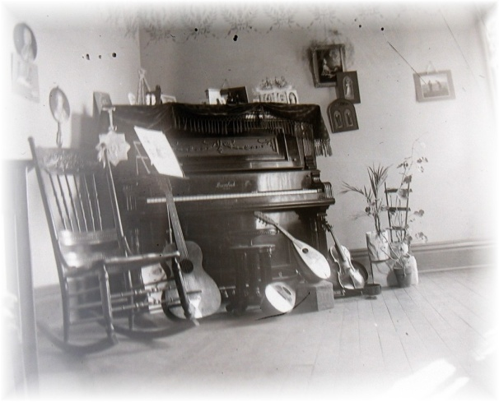Along the way, maybe we can promote the education and enjoyment of Bluegrass music and promote fellowship among all musicians and supporters who have a love for Bluegrass music.

This organization has a worthy purpose as evidenced in its mission statement. If we can educate, preserve, perpetuate and promote enjoyment amongst ourselves we will have served a greater good and enriched lives. As “music soothes the savage beast” let it also bring peace and relaxation to the soul of the people, as bluegrass is from the soul of America.

Watch for the next newsletter and our article when we will discuss “Traditional Instruments”.

IdaGrass Advertising

If you would like to purchase a half or full page ad in IdaGrass, the rates is as follows – $7.50/half page, $15.00/full page.

Short Classified ads, selling or looking for instruments or music can be places by ISBA member for free. Email [trueblue@wildblue.net](mailto:trueblue@wildblue.net) concerning questions or more information

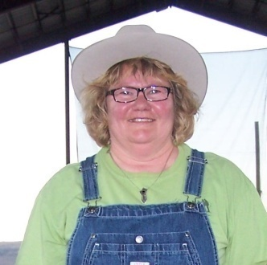**Local Bluegrass concerts help shake off the Winter Blues**

By Rayne Redman

Christmas over, a long winter still looming ahead and I’d been having the “bluegrass blues.” Two January bluegrass concerts snapped me out of it though. On January 7th our band played up in Lewiston at Valley Bluegrass Stage, put on by our own Scott and Karen Lombard. Two weeks later I was able to attend the Hotwire concert at the Kooskia Opera House. After second great night of bluegrassn’, I think I’m actually going to survive until the festival season begins. Both of these were very fun and successful concerts, featuring some of our own ISBA band members.

The Valley Bluegrass Stage is a series of bluegrass concerts put on every three months running from fall through spring. Scott and Karen rent the Clarkston High School auditorium and bring in some of the finest local bands around for a fun evening of bluegrass and acoustic music. The Valley Bluegrass Stage has already become a huge success. It was a very fun evening for everyone. One of the highlights for me was getting to hear the “Lightening Bugs,” 4 cousins, seven to ten years old, who can really sing and play well. My heart swelled as I sat there watching those kids. Way to go Lightening Bugs! What a great winter bluegrass evening.

Then just as those blues started setting in again I was able to attend another great bluegrass concert down at the Kooskia Opera House, featuring the great local bluegrass and country acoustic band, Hotwire. The doors open at 6:45 and we wanted to get there nice and early to get a good seat. Imagine our surprise when we arrived at 6:30 to find the parking lot and street completely full and people standing down the block waiting for the doors to open. I was a bit worried that we’d be sitting in the back. Luckily, even though it was a sold out crowd of around 200 people, we were able to get real good seats fairly close to the stage. The Kooskia Opera House is an awesome venue for a bluegrass concert. The owners really work hard to put on a nice show. They dress in 1800 period clothing and serve homemade pie from a 20 foot long wooden bar, with all the mirrors behind it and everything. As you wait for the show to begin they have a live piano music for your entertainment.

At 7:30 Hotwire took the stage and kept the momentum going with one kickin’ tune right after the other. Boy those guys can really flat-pick those guitars and the show was very entertaining. Our own newsletter editor Helen Smith is the newest member of Hotwire keeping the guys in time with her driving bass. As I sat there singing along, tapping my toes and watching their fingers fly across those strings those “bluegrass blues” were just melting away. I really enjoyed the entire concert right down to the sour cream raisin pie and bottle of Sarsaparilla.

If any of you are feeling those “bluegrass blues” like me you have another chance to catch the next Valley Bluegrass Stage Concert, Saturday April 16th at the Clarkston High School. Some of you Boise-area folks can catch the concerts with Chicken Dinner Road or at the Greer’s Bluegrass Barn. Head on out and shake off those “bluegrass blues”. You’ll leave ready to face the rest of winter with a skip, a hop and a lighter step as you slide into spring and the ISBA Spring Super Jam.

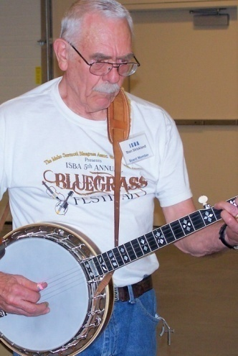**Contributions from the Board**

Stan Strickland is the board member contributing to this issue of IdaGrass. Stan lives in Boise with his wife, Trudee. Stan is a banjo picker and hosts a bi-monthly jam at their home. With permission from the author, Stan has offered a series of articles written specifically for guitarists, but the information can be helpful to other acoustic musicians, as well.

To Know It Is to Love It

By Jim Sanders

I’d like to show you what I have learned while looking at the guitar fingerboard. I have whiled away many a lunch hour studying the fingerboard. I think it is fascinating. After this series of article, I hope you will too.

Now, before your eyes glaze over and you go screaming into the night, here are just a couple of basics. If you have a hard time remembering the names of the notes that correspond to each string, here is a beginner’s trick: Elephants And Dogs Got Big Ears. The first letter of each work is the note from the fattest string to the thinnest. This is when you are playing open strings. If you refer to the diagram, all of the notes that are indicated result when you hold the string down at that position. Except for the top line (which is the names of the notes of the strings) When placing the capo, you will find that the notes along the G string correspond to the key, to which, you are changing.

Did you ever wonder why it is that when you place your capo at the second fret and play a G chord, it is now an A chord? The answer is this. Stay with me now, when you place the capo on the second fret, you have shortened the string. In other words, the capo now acts as the nut and allows you to play the same chord fingering as if you were playing in open G tuning, but the capo has changed the tuning to A. This reasoning follows for any of the capo positions. (Key of B, C, etc.)

I urge you to reread this last paragraph a couple of times while referring to the diagram below and to the fingerboard of your own guitar.

The Guitar Fingerboard

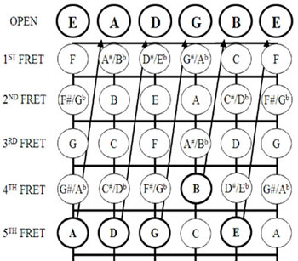

Fingeboard Image from: funkybluesmusic.com

Name__________________________________________________________________

Address________________________________________________________________

City____________________________ State________________ Zip_______________

Phone_________________Email Address___________________________________

IdaGrass, the ISBA newsletter is offered either in email or printed letter format. Using email saves the Association the cost of postage and printing. HOWEVER, because we want you to enjoy and look forward to the newsletter, we want you to receive the newsletter in the format with which you are comfortable.

I would like to receive the newsletter: 🞏 Email 🞏 US Postal Service

I am joining as: 🞏 New Member 🞏 Renewal Date: _________________­

Yearly membership/April to April: $15.00 (for an individual or family)

Please mail to: Idaho Sawtooth Bluegrass Association

c/o Trudy Strickland

                      5714 Centerbrook Dr.

Boise, ID 83705

If you have Ideas, ***Comments***, Questions, or Concerns

**Northern Zone**

ISBAzone.wmfSteve Gleason, Lewiston

(208)798-8280

Pete Northcutt, Grangeville

[pnorthcutt@mtida.net](mailto:pnorthcutt@mtida.net)

Will Williams

(208)839-2814

**Southern Zone**

John Boyer, Twin Falls

(208)733-4552

boyerj1@mindspring.com

**Middle Zone**

Bob Greer, Nampa

bobggreer@msn.com

(208)466-1719

Stan Strickland, Boise

(208)377-5326

**Webmaster -** Carolyn Johnson, Boise

[cthorse@gmail.com](mailto:cthorse@gmail.com)

**Membership:** Trudee Strickland

[stantrud@msn.com](mailto:stantrud@msn.com)

**Association Photographer –** Jim McCue, Payette

**IdaGrass Editor:** Helen Smith, Grangeville

[trueblue@wildblue.net](mailto:trueblue@wildblue.net)

**Check us out on the web: www.idahosawtoothbluegrass.org**