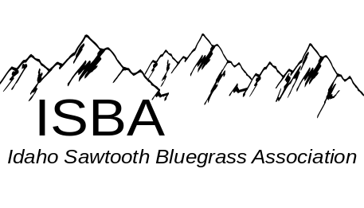
IdaGrass
Volume 4 Issue 3 May – June 2008

Inside this Issue:

Bluegrass Associations……………page 4

Bluegrass Festivals….…………….page 8

Concert Series Summer 2008……..page 7

Contact Us………………………...page 9

Disk Space………………………...page 4

IdaGrass Calendar…….…………..page 1

Membership Application………….page 9

Message from the President…........page 2

Round Valley Festival …………...page 3

Spring Super Jam ………………..page 5

ISBA Website:
www.idahosawtoothbluegrass.org

Bluegrass Events Calendar
Southern Zone Monthly Jam - 7pm at Gerties’ Brick Oven Cookery in Twin Falls.
Hot Jam, 1st Monday of the month
Slow Jam, 3rd Monday of the month
John Boyer 208-733-4552 boyerj1@mindspring.com
Middle Zone Monthly Jam –
Bill Elmer 208-466-1349 mandobil@mail2Musician.com
Bob Greer 208-466-1719
Northern Zone Monthly Jam, The Northern Zone is pleased to announce they are having two jams a month:
1st SAT at Orchards United Methodist Church, 1213
Burrell Ave., Lewiston Orchards, Noon - 5pm
3rd SAT at Highlander Community Room,
616 Warner, Lewiston Orchards. Noon - 5pm
Steve Gleason (208 798-8280
Pete Northcutt (208) 983-2277

Bluegrass In The Barn – May 17th, 7 pm, will feature Will Williams & Gravel Road will join the house band, Tradition

Chicken Dinner Road has been hired to perform at Les Bois Park for the three major horse races this year (KY Derby, Belmont Stakes, Preakness). We will perform on the following dates:
May 17 (1-4pm)
May 26 (1-4pm) (Memorial Day Festivities)
June 7 (1-4pm)

Carrie Hassler & Hard Rain, July 18th, 7pm @ Jewett Auditorium. See flyer page7.

The purpose of the Idaho Sawtooth Bluegrass Association:
- To preserve and perpetuate Bluegrass music as a heritage of our country;
- To promote the education and enjoyment of Bluegrass music;
- To promote fellowship among all musicians and supporters who have a love for Bluegrass music, regardless of race, creed, color, ethnicity, or ability to play music.

Message from the President

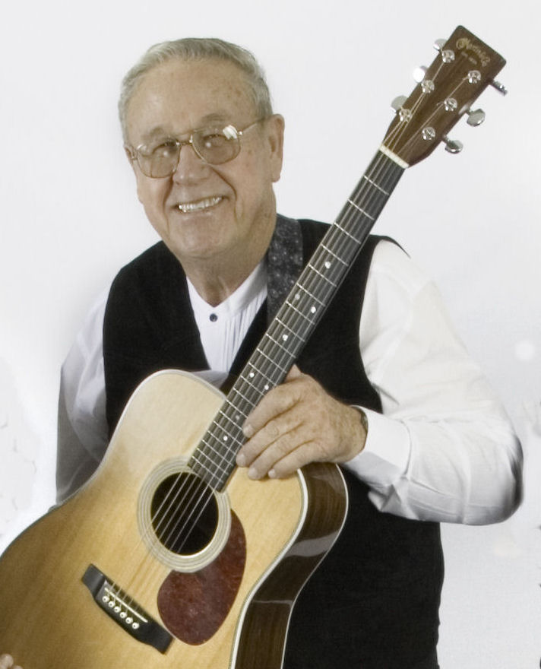
It seems like only a few days ago that I last wrote a note for IdaGrass. My, how time flies when you are having fun. The Kamiah Jam was a memorable event and if you missed going you missed one of the finer times of life. The ISBA volunteers, who put the Kamiah Jam together and played host to the rest of us, deserve a great big thank you. Thank you for providing a great event to look forward to each spring.

The Round Valley Labor Day Festival is progressing through the planning stages. I hear that Mike Compton, of "Oh, Brother, Where Art Thou?" fame, will be in attendance. Add to that Bill Evans on the banjo and it is beginning to sound like an event you should not miss. Check our web site for complete up-to-date info on who will be there.

We are also planning a work detail for getting the Round Valley Festival site improved and readied for Labor Day weekend. Tentative plans are to have volunteers to join together for the first week of June (or whatever part of the week you can join us) and help work and enjoy a time of camping and jamming. Please let me know if you plan to attend so we can plan accordingly. I need to know how much help and what kind of tools we will have to work with. We plan to clear camping sites of brush, logs, etc. It will be a good time to get a feel of the facilities and plan in detail how to best utilize the area.

Since there will be no signs to follow, these are the directions to the site coming from Boise on Hwy 55. Just past the milepost marker #101, as you break into Round Valley, turn to the right (South) on Round Valley Road for 8/10th of a mile. Turn east on Gray Lane for 1 mile. Turn South on Spoor Road to the south end of the valley.

My cell phone (ATT) worked the last time I was there. Call me at home (208-466-1719) to plan the week, or call my cell during the week (208-484-8678).

The other great fun event has been going to see Cedar Hill at the Star Community Center. For all that missed this great show you have my sympathy. You missed an outstanding appearance of a very professional Bluegrass Band. Thank you to Dennis Stokes and DBR for bringing them to our area.

We are still in need of volunteers for the Round Valley Bluegrass Festival. Don't let all the fun pass you by. Come and join in with the rest of us. Check in with Sydney for details.

Contact info for Sydney: sydland1z@juno.com, 206-542-7591

Keeping the Tradition,
Bob Greer, President ISBA

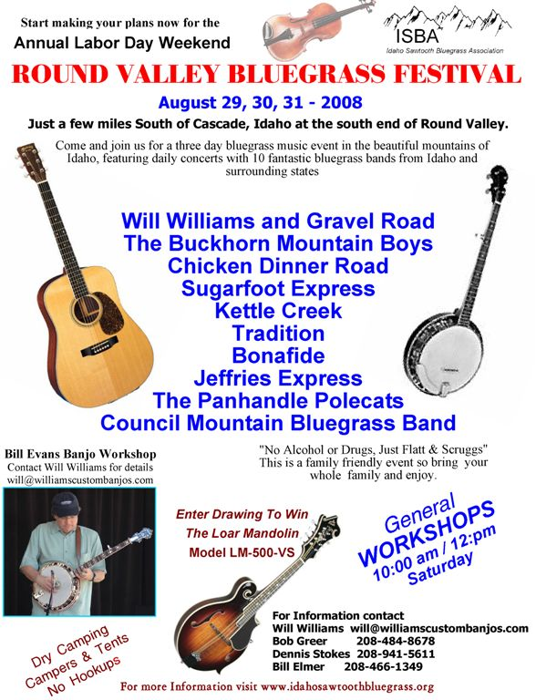

Disc Space by Mike McCarthy
ISBA Member, Mike McCarthy lives in Twin Falls and thinks, “You can never have too much banjo.” Mike has agreed to share and review newly released and other CDs with our readers.

Ron Hillier, “Leavin’ Lonesome” 5string@onewest.net
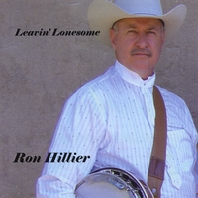
Ron is something of a fixture in the Southern Idaho bluegrass scene. I knew this solo project would have rock solid banjo playing, but was pleasantly surprised by everything else. Ron plays some fine guitar and mandolin (check out Big Sciota). I was most impressed with his songwriting. There's a plethora of interesting original songs, such as the title cut, Leavin Lonesome, often with references to Idaho people or places (Idaho Soldier, Taylor Mountain). There are tasteful instrumentals (Rudy Corbet and Sugarloaf). Ron is capably assisted by Sean Dean on fiddle and his son, Ryan Hillier, on upright bass. If you liked the traditional sound of Deadline Ridge, then you will definitely like this CD.

David Grisman, “David Grisman Bluegrass Experience”, Acoutcidisc.com

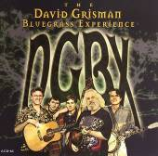
If you are only familiar with the jazz that David Grisman plays with his quintet, you may not know that he loves and plays great traditional bluegrass. This CD contains the Monroe brothers’ "I'm Rollin On,” the Stanley Brothers’ "Are You Afraid to Die," and the Carter Family's "Engine 143." It also contains the Grisman classics "Dawggy Mountain Breakdown" (his homage to Earl Scruggs and the theme for the Car Talk radio program) and the classic "Old and In the Way." He is backed by some of the best pickers and singers in the Bay area - Keith Little on banjo and vocals, Jim Nunnaly on guitar and vocals, Chad Manning on fiddle, and Samson Grisman (David's son) on upright bass. Even the most die-hard traditional bluegrasser will enjoy this CD.

A note from a member…….
This was my first year attending the ISBA spring Super Jam in Kamiah. What a great time. In the past two years, when I would return home from Portland, I would hear about how great a time was had at this event. This year was even better than I’d heard. The weather even tried to cooperate. There were plenty of jams to play in over the weekend and the stage show went off super. The master of ceremonies kept things moving right along. The resort is sure willing to work with the Association on whatever the needs were. I enjoyed myself so much that I forgot to take any photos, so anyone who did, that would care to share one or two of Rich and/or me playing or whatever, I would so graciously accept them. Definitely looking forward to next year.
An appreciative member, Carol Gregg

Neighboring Bluegrass Associations
Arizona Bluegrass Association –
www.azbluegrass.org

California Bluegrass Association –
www.cbaontheweb.org

Idaho Bluegrass Association –
www.smithfowler.org/bluegrass/IdahoBGindex.htm

Inland Northwest Bluegrass Association –
www.mtbluegrass.com

Montana Rockies Bluegrass Association –
www.mtbluegrass.com

Oregon Bluegrass Association –
www.oregonbluegrass.org

Washington Bluegrass Association –
www.washingtonbluegrassassociation.org

Spring Super Jam 2008 Super,
Thanks to Many!
Well, the bluegrass festival season has officially begun. We had a wonderful weekend at the ISBA sponsored Spring Super Jam held April 25-27th in Kamiah Idaho. The weather started off with a respectable rain on Friday morning, but it gradually improved. By Saturday afternoon, it couldn’t have been any better, had we custom ordered the warm sunshine.
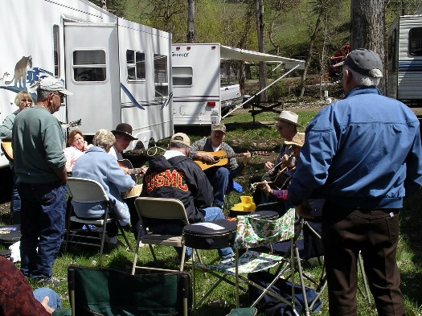
Our special “thanks” to the Lewis Clark Resort. They went ‘above and beyond the call of duty’ to have everything up and ready for us when we got there. As the resort ownership had changed since last year, they didn’t know quite what to expect, but they were terrific – a new stage for the concert and community rooms for the open mic, workshops and jamming. The weekend, true to its name, offered plenty of super jamming every day and late into the evening.
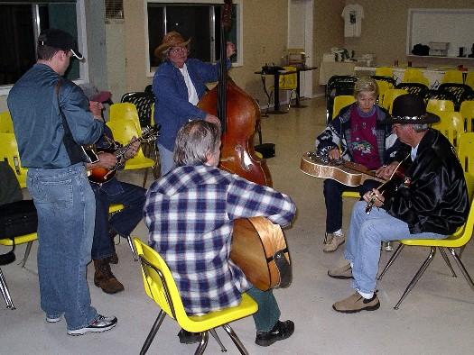
People gathered around campers and in cabins and community rooms. A “thank you” to those who brought wall tents, complete with heat and lights – there was some great jamming in those places.
On Friday night, an audience enjoyed the impromptu bluegrass created by those people who gathered their bluegrass buddies and participated in the “open mic” activity. It was great to see people ‘band together’ (sorry for the pun) and have such a good time playing music. The “open mic” lasted about an hour and a half, after which people gathered to jam. “Thanks” to those who participated.

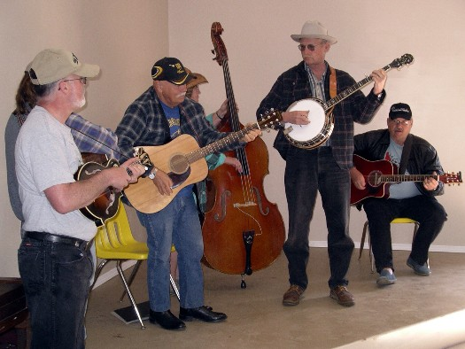

The instrument workshops were well attended on Saturday morning. When I asked one student about his experience, he said, “I am new to bluegrass. I have attended about a half dozen workshops in the last couple of years. This was the best workshop I have attended. Instead of the teacher just telling us what to do, Raynae had us do it, to try and get hands on.” A heart felt “Thank you” to all those instructors who graciously gave their time to teach.
We had a great crowd of about 600 people for the concert Saturday evening, most campers and many from the surrounding communities. I was delighted to see people prepare, with blankets, hats and sleeping bags, for the cool temperature that came once the sun went down.

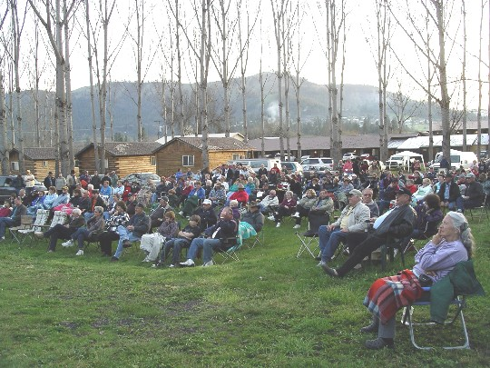

I think that Chicken Dinner Road may have started a new fashion trend with their “stylin” head gear. Thank you to the bands who donated their time and travel to provide a wonderful concert.
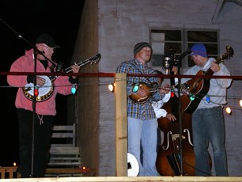
“Thank you, Rich Gregg,” who did a wonderful job as the emcee that night. I think you were born for that job! Sunday morning dawned bright and sunny. Folks gathered in the community room to pick, sing and share their bluegrass gospel favorites.
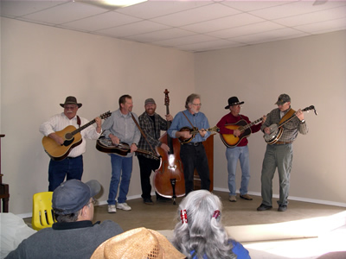

The end of the gospel show marked the end of the weekend and everyone packed up and headed for home.
Just as a side note, if there were things you either really, really liked, or really, really disliked, please send an email or make a phone call. Contact information for board members can be found at the back of this newsletter. (Photos by Carolyn Johnson)

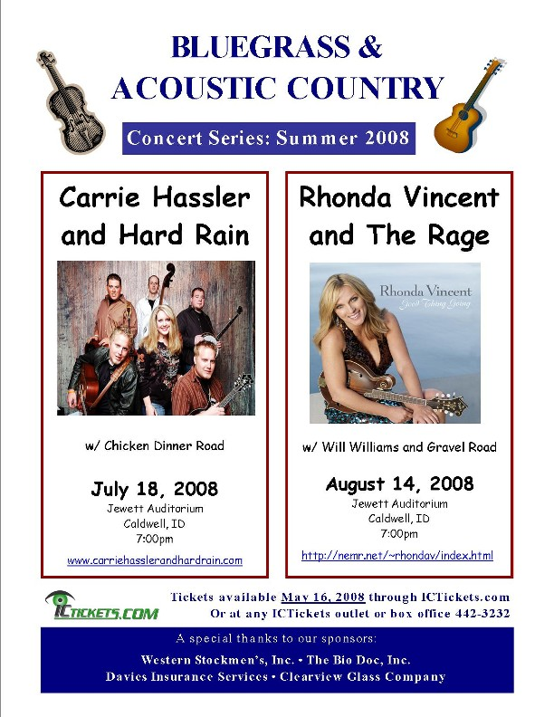

Bluegrass Festivals

PRESCOTT BLUEGRASS FESTIVAL
June 21 – 22, 2008
Prescott, AZ, two hours north of Phoenix.
Prescott is an old western town and retirement community at 5,000-feet elevation with very moderate weather. Free of charge, this is a community event presented on the County Courthouse Square. Seating is on our green lawn under large shade trees.
This year we feature The Gibson Brothers, Heidi Claire, Sons and Brothers, Sawmill Road, and Fire Ridge. All very exciting entertainers.
There is dry camping and lodging nearby.
www.prescottbluegrassfestival.com

SACAJAWEA BLUEGRASS FESTIVAL & DUTCH OVEN RENDEZVOUS, June 13-15
Sacajawea State Park, located near Tri-Cities (Richland, Kennewick and Pasco, WA) just off Highway 12.
www.sacajaweabluegrassfestival.com

BITTEROOT VALLY BLUEGRASS FESTIVAL, July 11-13
THIS FESTIVAL HAS BEEN CANCELLED.
www.mtbluegrass.com

BANNOCK COUNTY BLUEGRASS FESTIVAL, August 22, 23, 24
Bannock County Fairgrounds in Pocatello Idaho
www.bannockcountybluegrassfestival.com

ISBA ROUND VALLEY BLUEGRASS
FESTIVAL, August 29-September 1
See flyer for this festival on page ?
Round Valley, Idaho (just south of Cascade, ID on State Hwy 55)

Other Music Gatherings
Pasture Pickin, May 25th–31st. Libby, MT, 5502 Pipe Creek Rd. Contact Dorothy Berg (406)293-6608

Camp & Jam, June 13-15th. Dworshak State Park, near Orofino, ID. Contact
Kristi Stephens (208)476-5994

Rodeo Pickin, June 23-29th. Newport, WA, on First St. & Garden Ave.
Contact Ralph & Val Billbe (208)437-2044

Fraser Park Camp & Jam, Aug. 1st–3rd. Fraser Park, ID. (Off Hwy 12 and up Greer Grade on Hwy 11) Contact Linda & Mike Beard (208)435-4806

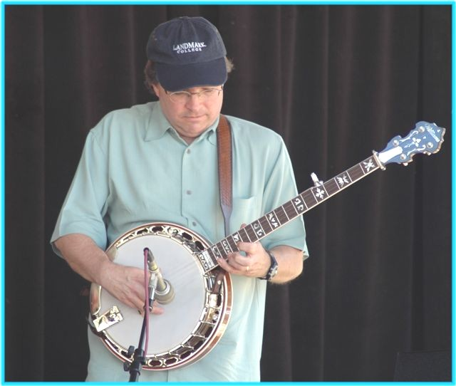
Bill Evans Coming to Idaho

“Bill Evans is well-known within the bluegrass music community not only as a musician, but also as a teacher, writer and scholar.” Banjo players in Idaho have the unique opportunity to have Bill Evans coming to give banjo workshops over Labor Day weekend, at the ISBA Round Valley Bluegrass Festival. Two different classes will be offered: “Picking it Solid” and “Backup Essentials.” The class fee is $50.00 per class, per student. If you are interested in signing up for class, please email Will Williams, will@williamscustombanjos.com.
Sign up early as space is limited. Additional information can be found on the ISBA website: http://www.idahosawtoothbluegrass.org

Application for ISBA Membership

Name________________________________________________________________

Address______________________________________________________________

City____________________________ State________________ Zip_______________

Phone___________________________ Email Address___________________________

IdaGrass, the ISBA newsletter is offered either in email or printed letter format. Using email saves the Association
the cost of postage and printing. HOWEVER, because we want you to enjoy and look forward to the newsletter,
we want you to receive the newsletter in a format with which you are comfortable.

I would like to receive the newsletter □ Email □ US Postal Service

□ New Member □ Renewal

Date_____________________

Yearly membership: □$10/individual □ $15/family

Please mail to: Idaho Sawtooth Bluegrass Association
PO Box 123 White Bird, ID 83554

If you have Ideas, Comments, Questions, or Concerns

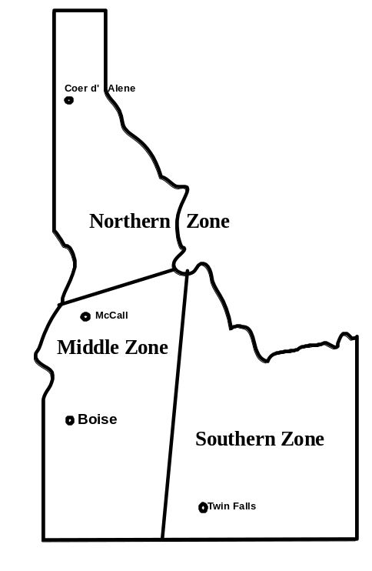
ISBA President

Bob Greer: bobggreer@msn.com
208-466-1719

Northern Zone

Steve Gleason: 208-798-8280

Pete Northcutt: pnorthcutt@mtida.net

Southern Zone

John Boyer: 208-733-4552
boyerj1@mindspring.com

Middle Zone

Bill Elmer: 208-466-1349
mandobil@mail2Musician.com

Bob Greer: bobggreer@msn.com
208-466-1719
Stan Strickland

Board Chairman

Will Williams: will@williamscustombanjos.com

Webmaster

Carolyn Johnson: cthorse@gmail.com

IdaGrass Editor:

Helen Smith: trueblue@wildblue.net

